Review and Evaluation of Pharmacology and Toxicology Data

Division of Medical Imaging and Radiopharmaceutical Drug Products
HFD-160
Reviewer: Adebayo, A. Laniyonu, Ph.D.

Chemical Name: N-13 Ammonia

CAS Number: 34819-78-8

Structure:
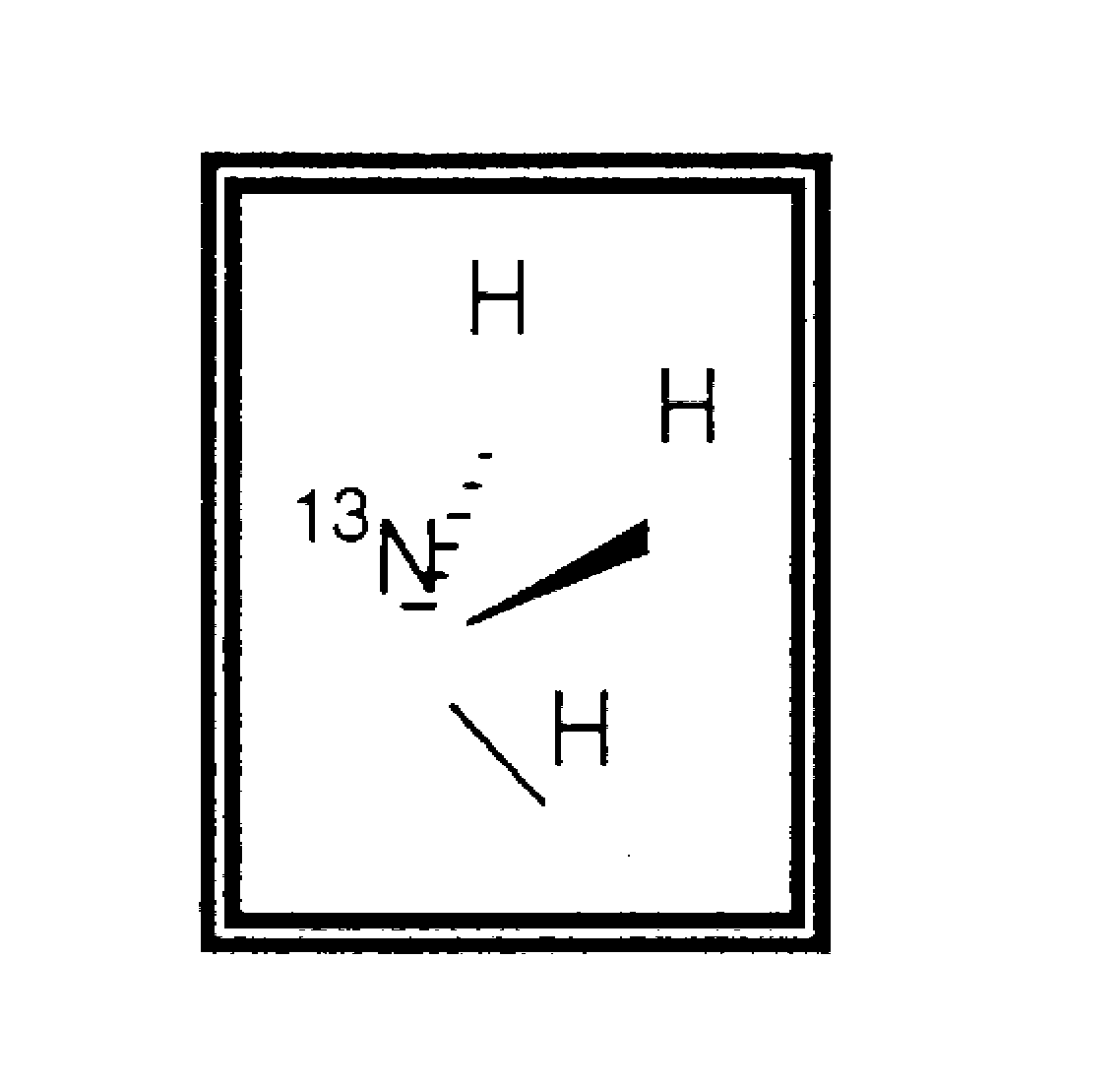
Drug Class: Positron Emission Tomography (PET) Radiopharmaceutical

Indication: Assessment of myocardial blood flow

Clinical Formulation (and components):

N-13 ammonia will be formulated as a “no carrier added” preparation by various PET centers, this review therefore is not considering a known formulation. Reported dose range is 8-25 mCi with specific activity range of 200-400 mCi per micromole. The worst case scenario would predict ammonia concentration of 0.125 micromole for the 25 mCi dose. Different production pathways may impact on the purity and toxicological profile of N-13 ammonia. Depending on the manufacturing process, likely impurities and by-products include aluminum or titanium ion. Levels of less than 1 ppm reported are considered to be of no toxicological relevance.

Route of Administration: Intravenous

Introduction/Drug History:

There are many published articles concerning the clinical use of N-13 ammonia in conjunction with Positron Emission Tomography (PET) to measure myocardial blood flow non-invasively [1,2,3,4]. PET radiopharmacueticals are usually manufactured close to the site of use in hospitals and clinics due to the relatively short half-life of these products. Different PET centers will therefore be responsible for the production. Thus unlike a conventional application, this review is not considering a known formulation. A major purpose of this review is to review the available scientific literature in an attempt to examine the scientific basis of use, and to determine whether Pharmacology/Toxicology studies typically conducted and considered critical to support the safety of an NDA application have been reported in the literature. This is not a typical NDA review, because the experiments upon which the scientific evidence are based were not conducted with NDA format in mind. Nevertheless, all the articles were published in peer reviewed journals and the majority of the findings were reported from multiple laboratories and centers. It is hoped that the review will (1) identify the concepts that are scientifically valid and that appear to have general support within the scientific community and (2) identify the areas where more information is required.

Previous clinical experience: see supervisory medical officer review.

Pharmacology:

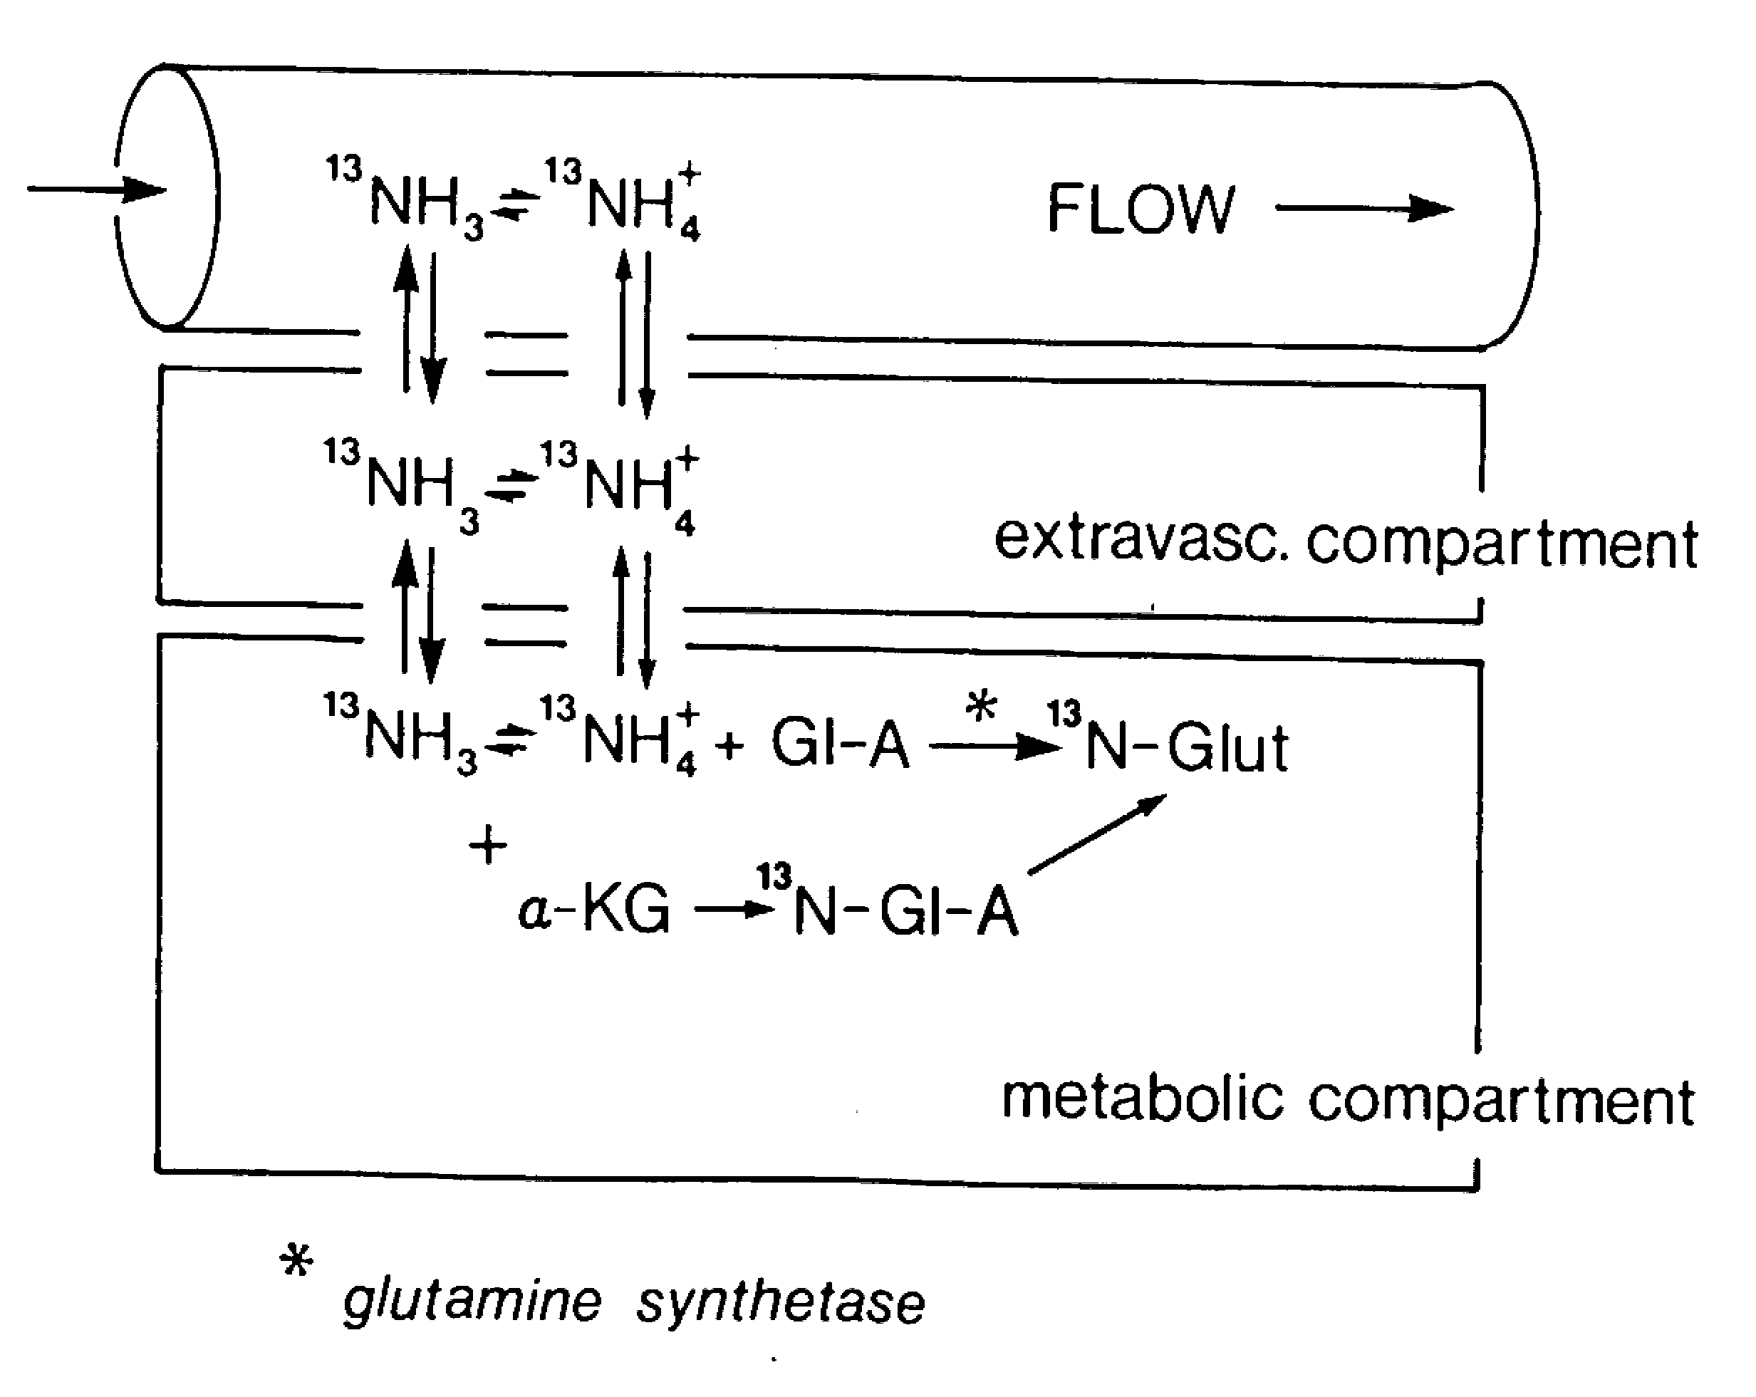
The use of N-13 ammonia in combination with Positron Emission Tomography for non-invasive measurement of myocardial blood flow is well documented in both clinical and non-clinical studies [5,6,7]. At a very basic level, N-13 ammonia is functioning as an extractable diffusion indicator. It diffuses freely across capillary and cellular membranes and in the myocardium, is metabolically incorporated into glutamine by the enzyme glutamine synthetase. The N-13 ammonia essentially becomes trapped as N-13 glutamine in view of the fact that glutamine is slowly released from the cell. Implicit in this schema are the assumptions that the level of the enzyme glutamine synthetase is not the rate limiting step, and that the intracellular and extracellular N-13 ammonia pools equilibrate rapidly [8,9].
Fig 1: Model for the uptake and retention of N-13 ammonia in the myocardium. Gl-A = glutamic acid; Glu = Glutamine; α-KG = α- ketoglutarate (From Schelbert et al. 1981, Circulation, 63, 1259-1272). For ease of mathematical handling and modeling, a three compartmental model is proposed; Vascular –representing N-13 ammonia in the coronary capillaries, extravascular- representing N-13 ammonia in the extravascular compartment , the metabolic comparment represents NM-13 ammonia metabolically trapped as glutamine intracellularly. The glutamic acid-glutamine is the major trapping mechanism with minor contribution from the ketoglutarate-glutamic acid reaction.

The uptake of N-13 ammonia is governed by two main factors: the capillary blood flow and the extraction efficiency, i.e., the avidity with which the N-13 ammonia is extracted from the blood into the extravascular space. N-13 ammonia exists in the blood primarily in its ionic species, the ammonium ion. It is extracted from the blood via mechanisms including ammonium ion substituting for potassium ion in the sodium-potassium pump or through passive diffusion across the capillary and sacrolemmal membranes. The extracted N-13 ammonia is retained by the myocardium through incorporation into the pool of amino acids. The trapping by the myocardium results in good contrast myocardial images. Various studies have demonstrated that at flow rates between 0 to 300 ml/min/100g, there is a linear relationship between N-13 myocardial tissue concentration and flow. At higher flow rates, a non-linear relationship ensues, and myocardial blood flow will be underestimated by the N-13 ammonia method. The underestimation has been attributed to the fact that under conditions of very high flow, metabolic trapping of N-13 ammonia becomes the rate-limiting step [5,10].
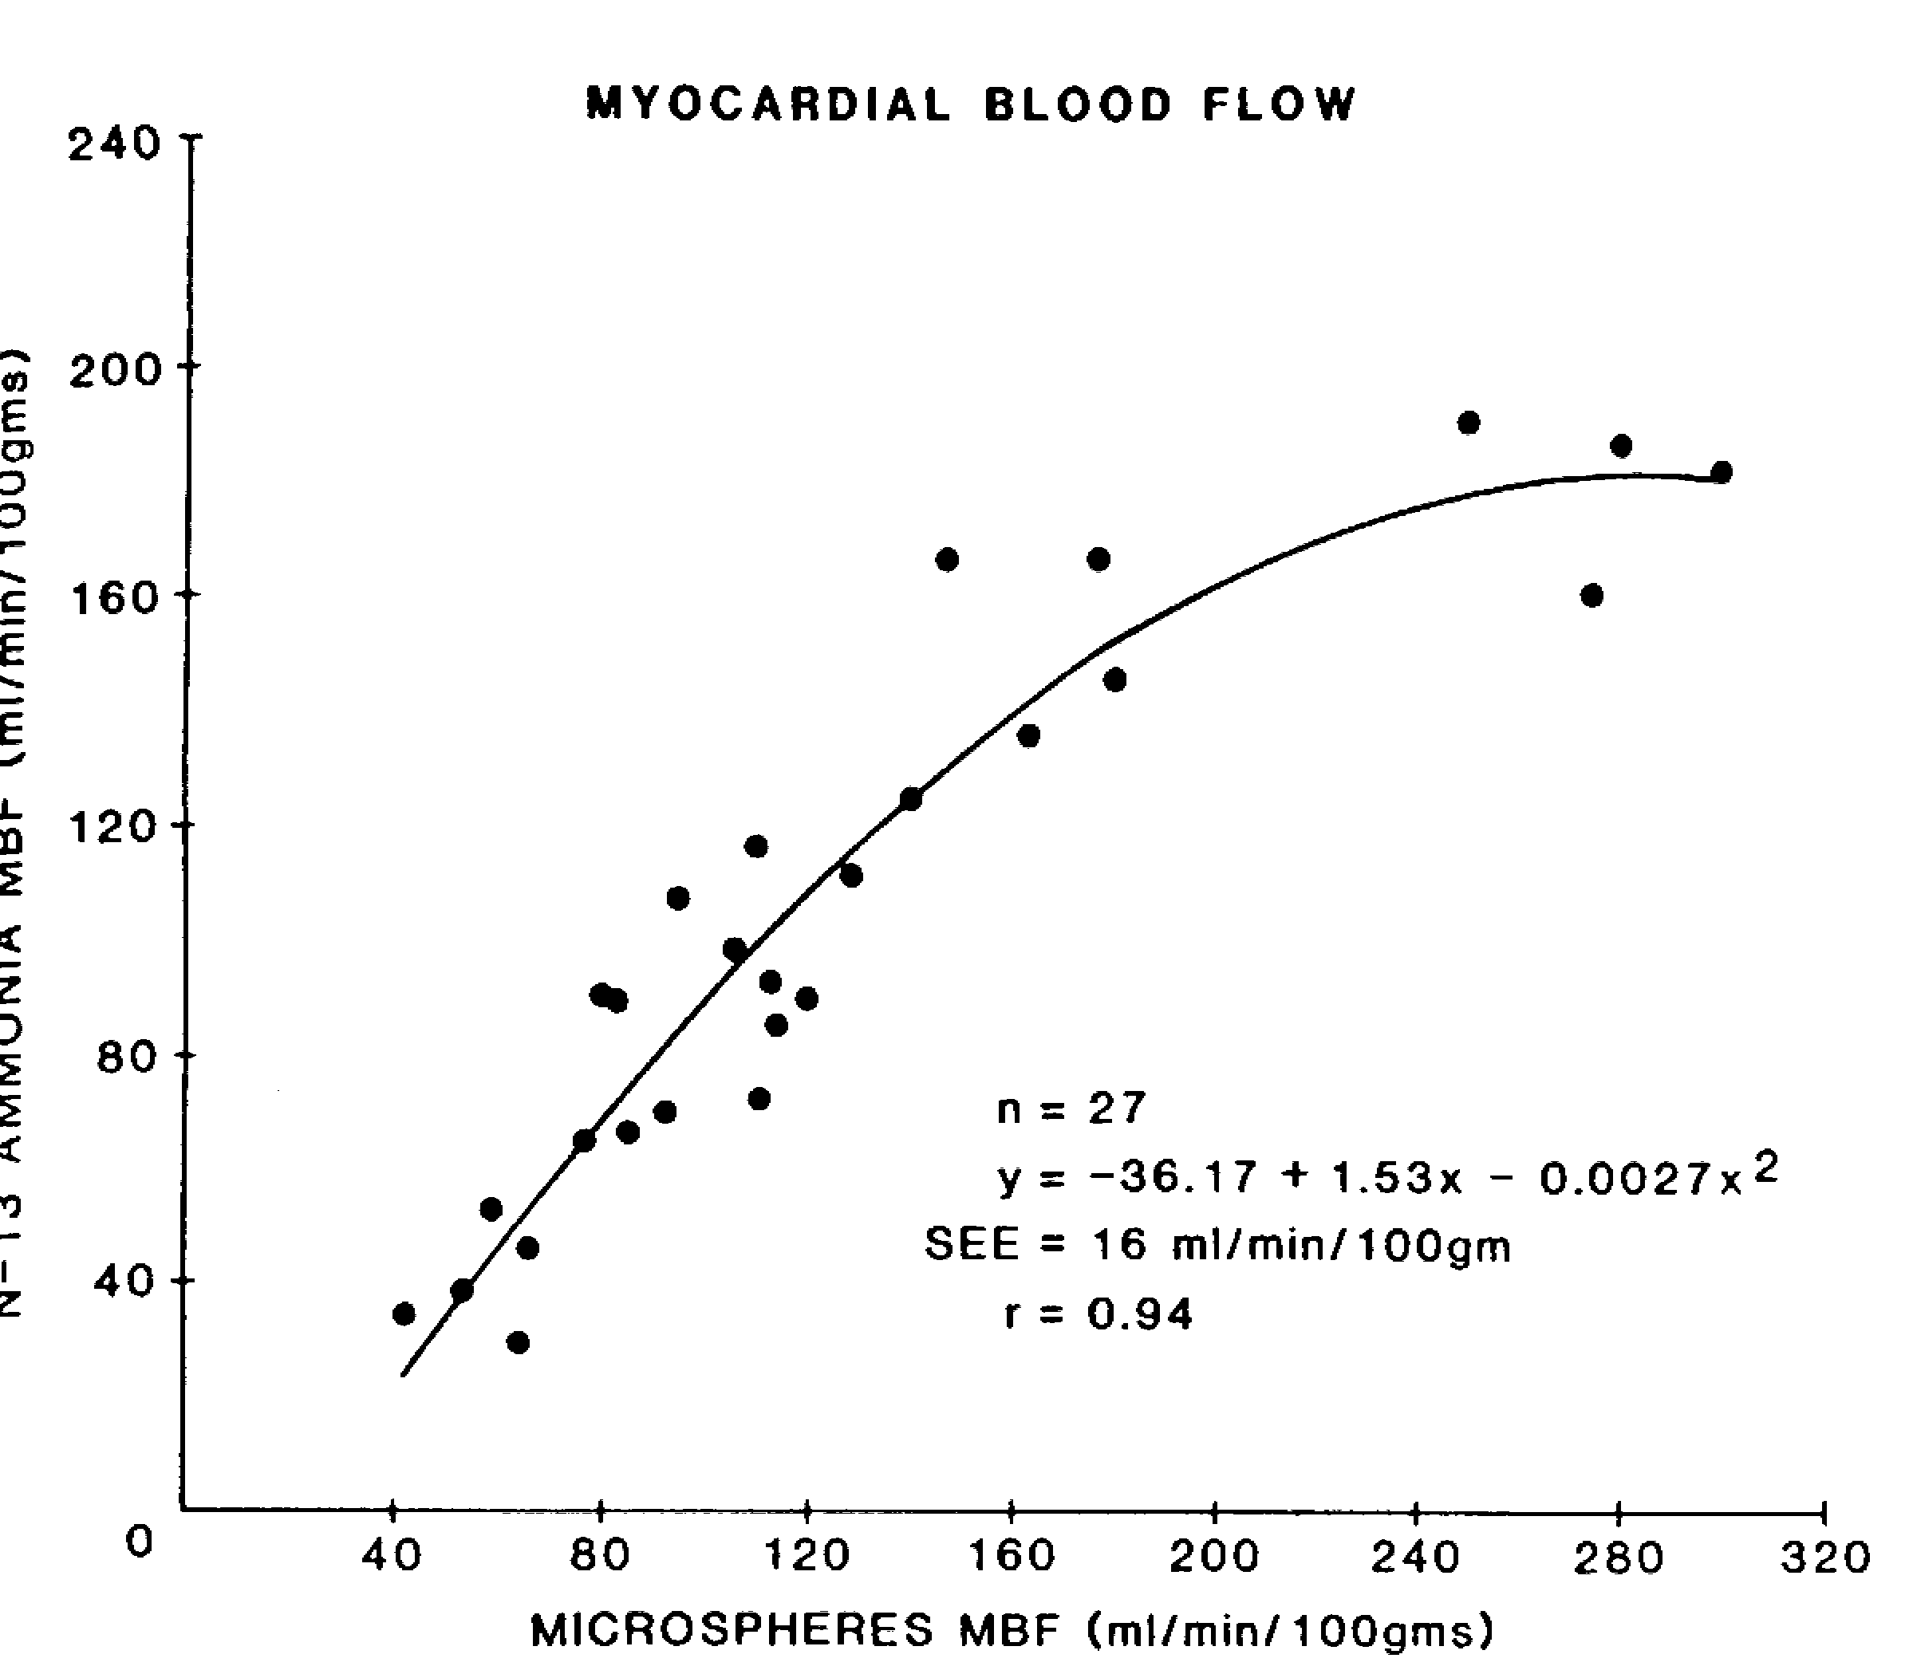
Fig: 2 Relationship between regional myocardial blood flow determined with the microsphere technique and N-13 ammonia -positron emission tomography (From Anil Shah et al. JACC 1985, 92-100)

A kinetic approach, separating extraction from retention has been developed to overcome this limitation [9,11]. It was suggested that N-13 ammonia may not accurately reflect myocardial blood flow during conditions of low _{p}H, reduced levels of intracellular adenosine triphosphate, changes in the cardiac transmembrane gradient of ammonia or inhibition of the activity of glutamate synthetase since N-13 metabolic trapping depends on the activity of the glutamic-acid-glutamine pathway. Other factors that may impact on the accuracy of the measurement are the integrity of the myocardial cell membrane and alteration in cardiac lipid metabolism [8,12]. While these possibilities can not be ignored, Schelbert and colleagues [8] demonstrated that metabolic trapping is relatively constant over a wide range of hemodynamic and metabolic conditions in dogs.

Pharmacokinetics:

N-13 ammonia rapidly clears from the circulation following intravenous injection. The results of the study by Lockwood et al. (1979) [13], indicate that ammonia clearance is a first order process at normal, and moderately elevated ammonia concentrations. N-13 ammonia is the principal component in the blood during the first two minutes, decreasing in a species dependent manner to between 25 % (dog) and 50 % (humans) within five minutes. The elimination half life of N-13 ammonia in human blood is about 3 minutes while its myocardial half life has been estimated to be less than 2 minutes. The principal metabolites in the blood of humans and dogs are N-13 urea and N-13 glutamine, accounting for over 80% of the metabolites by 10 minutes. N-13 labeled acidic amino acids such as glutamate or aspartate account for less than 1%. The physical half life of N-13 ammonia is 9.96 minutes.

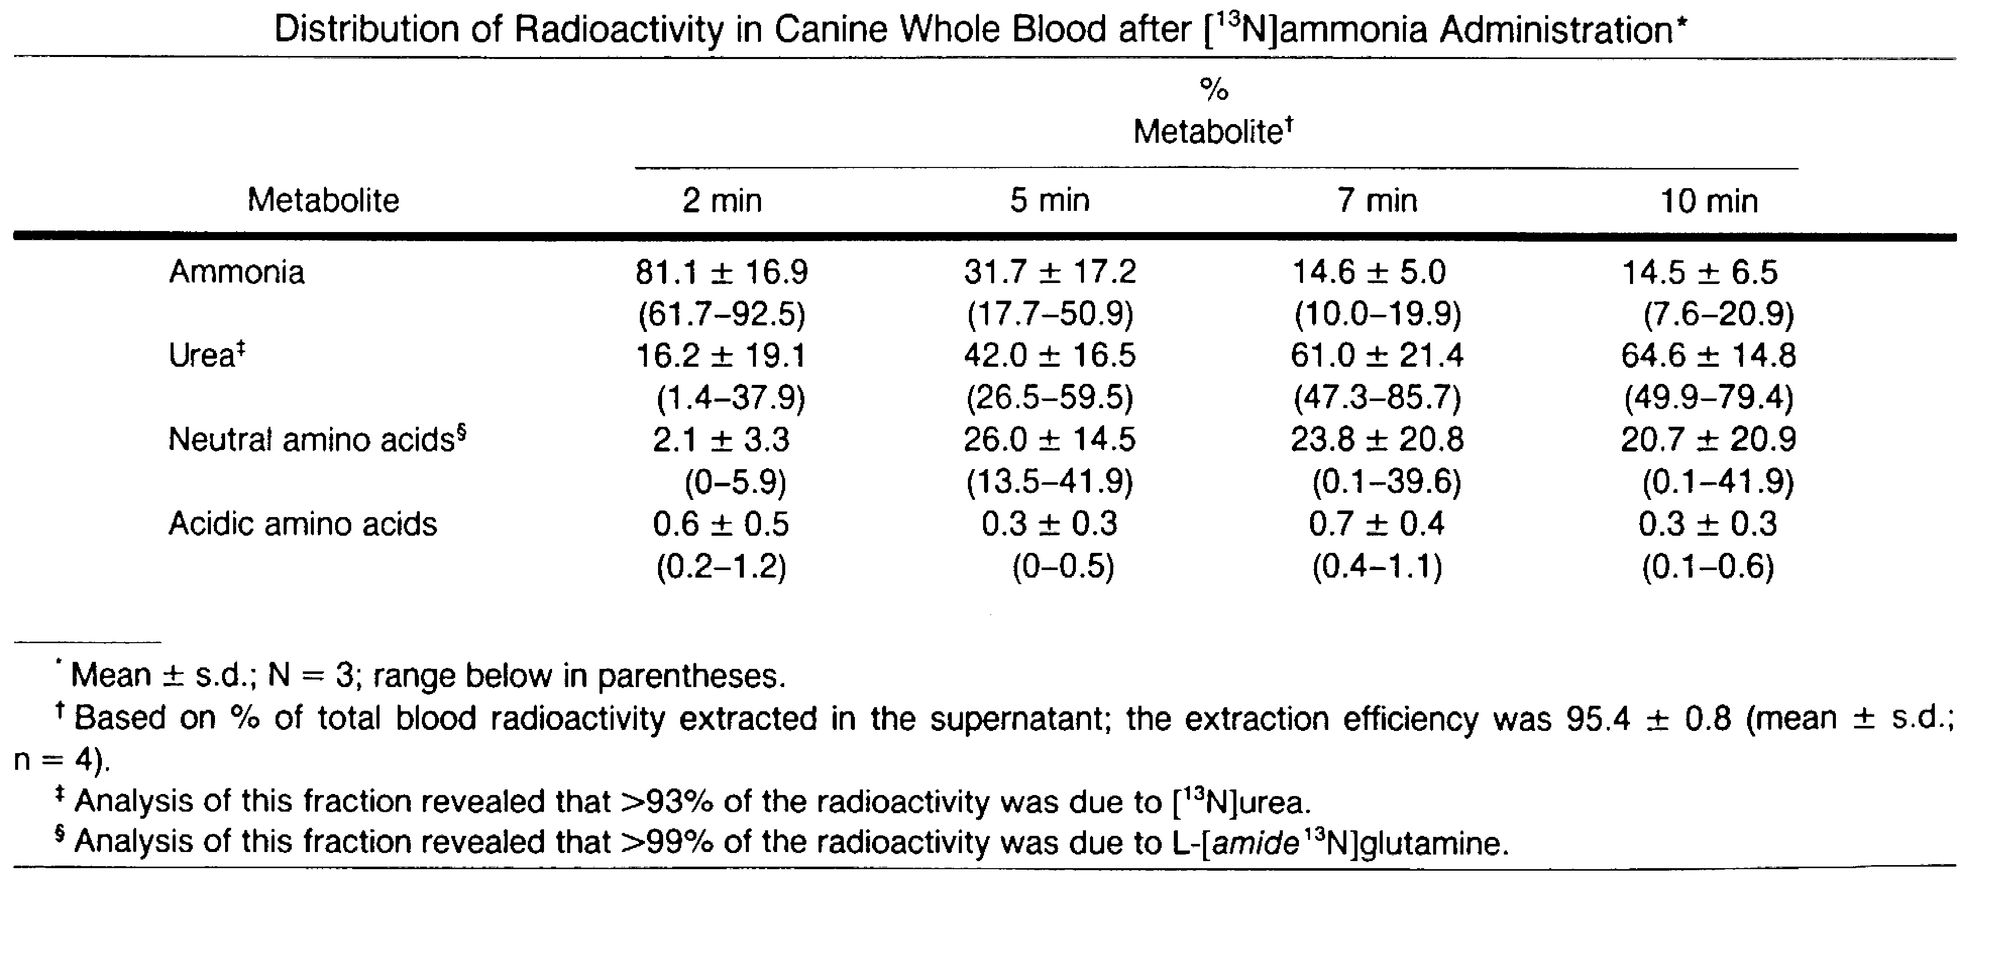
From Rosenspire et al. (1990) J.Nucl Med 31: 163-167

Quantification of blood flow using N-13 ammonia kinetics requires accurate determination of the N-13 ammonia activity in the blood. In view of the fact that these metabolites are rapidly formed, myocardial blood flow uncorrected for the contribution of these metabolites to the arterial input N-13 ammonia level would tend to overestimate the activity that is actually due to N-13 ammonia [13,14,15]. In view of extra cardiac formation of both glutamine and glutamate and the fact that glutamate is avidly taken up by human myocardium [16], the question arises as to whether the cardiac PET image reflects the sum total of extracted N-13 ammonia plus N-13 labeled glutamine and glutamate. However, N-13 glutamate is a very minor metabolite accounting for less than 1% of the total while Rosenspire et al. (1989) [14] indicated that the uptake of glutamine by the heart is negligible.

N-13 ammonia uptake is mainly by the heart, brain, liver, urinary bladder, kidneys and skeletal muscle. In both the myocardium and the brain, N-13 ammonia is removed by single pass extraction becoming metabolically trapped within the tissues by incorporation into the cellular pool of amino acids.

The kidney through glomerular filtration excretes urea [11].

Toxicology:

No study addressing the toxicology of N-13 ammonia was identified. However, the pathophysiology of excess ammonia is described in medical textbooks. Elevation of blood ammonia level secondary to seriously impaired liver function occur in several clinical situations since the liver is the major site of ammonia detoxification in the body. The skeletal muscle becomes an important site for metabolic trapping of ammonia in cases of advanced liver diseases and portal-systemic shunting [13]. In such cases, experimental data in rats and to some extent in humans, show increases in the rates of ammonia uptake from the plasma and of glutamine release by the skeletal muscle in cases of chronic liver disease and hyperammonemia. [13] Moreover, in vitro experiments using rat skeletal muscle indicate that the concentration of ammonia in the muscle is rate limiting in muscle glutamine production.

The blood ammonia concentration is less than 35μmol/L. The low level is important, as ammonia is toxic at high concentration and causes neurological problems [17]. The problem of defining toxic levels is compounded by technical difficulties in measuring ammonia level. Ammonia levels more than twice the normal range for a particular laboratory is considered significant, and a serum level greater than five times normal is a medical emergency [18]. Acute ammonia toxicity in humans rapidly produces coma, profuse sweating, grunting respiration, vomiting, diarrhea, and decerebrate rigidity with or without seizure [18]. The LD₅₀ of intravenously administered ammonium chloride in rats is 30mg/kg [19]. As For the N-13 ammonia-PET procedure, total amount of ammonia usually administered is less than 0.02μmol/L. This amount of ammonia will not cause a significant alteration in the circulating level of ammonia in the body.

Carcinogenicity:

No study addressing the carcinogenicity of N-13 ammonia was identified.

Immunotoxicology:

No study addressing the immunotoxicology of N-13 ammonia was identified.

Reproductive Toxicology:

No study addressing the reproductive toxicology of N-13 ammonia was identified.

Genotoxicity:

No study addressing the genotoxicity of N-13 ammonia was identified.

Overall Summary:

The purpose of this survey of published articles on N-13 ammonia is two folds. (1) Examine the scientific basis of its use to measure myocardial blood flow non-invasively. (2) Determine whether pharmacology/toxicology studies typically conducted and considered critical to support the safety of an NDA application have been reported in the literature.

The pharmacological basis of action seems to be well understood. There is sufficient scientific evidence in the literature to support the use of N-13 ammonia in conjunction with Positron Emission Tomography (PET) to measure myocardial blood flow. As stated in the pharmacology section of this review, N-13 ammonia is functioning as an extractable diffusion indicator. The mathematical, pharmacokinetics and biochemical principles involved appear to be rational, and generally accepted within the scientific community. Impact of confounding factors such as extra cardiac formation of glutamine and glutamate, extraction efficiency of N-13 ammonia at high myocardial flow rate and changes in metabolic conditions on the accuracy of data generated were addressed in the literature surveyed. This reviewer concurs that there is sufficient evidence to support the concept that the trapping of N-13 ammonia in the myocardium as N-13 glutamine is the “pharmacological basis of action” of N-13 ammonia as used in PET studies to measure myocardial blood flow.

The issue of whether pharmacology/toxicology studies typically conducted and considered critical to support the safety of an NDA application have been reported in the literature was examined. No study specifically addressing the toxicology, carcinogenicity, genotoxicity, reproductive toxicology or immunotoxicology of N-13 ammonia was identified in the literature. However, two factors ameliorate the lack of data; Extensive clinical experience without reports of safety related concerns (see supervisory medical officer review) and the fact that N-13 ammonia is an endogenous constituent administered at a very low dose. Relative to blood concentration, the amount of ammonia contained in PET applications is small and not expected to pose any problem. N-13 ammonia will be formulated as a “no carrier added” preparation by various PET centers. Radiation dose range is 8-25 mCi with specific activity range of 200-400 mCi per micromole. The worst case scenario would predict an ammonia concentration of 0.125 micromole for the 25 mCi dose. The physical half-life of N-13 ammonia is 9.96 minutes. Depending on the manufacturing process, likely impurities and by products include aluminum or titanium ion. Levels of less than 1 ppm reported are considered to be of no toxicological relevance.

Overall, N-13 ammonia is used to measure myocardial blood flow in humans. For such use, only low doses are required which would not be expected to alter the normal blood concentration of this endogenous constituent. The pharmacological basis of action is well understood and clinical evidence suggests that N-13 ammonia as used in the literature is essentially non-toxic to humans. Although not all data typically required by pharmacology/toxicology in support of an NDA application can be identified in the literature survey, it is the considered opinion of this reviewer that additional non-clinical data are unnecessary at this time to permit a decision that the drug substance is reasonably safe.

Recommendations:

It is recommended that N-13 ammonia be considered for approval for measurement of myocardial blood flow

Internal Comments: None

Reviewer’s Signature:
Adebayo, A. Laniyonu Ph.D.

Date

Team Leader Concurrence:
Nakissa Sadrieh, Ph.D.

Date

References:

1. Gould, L.K., Goldstein, R.A., Mullani, N.A., Kirkeeide, R.L., Wong, W.H., Tewson, T.J., Berridge, M.S., Bolomey, L.A., Hartz, R.K., Smalling, R.W., Fuentes, F. & Nishikawa, A. (1986) Noninvasive assessment of coronary stenoses by myocardial perfusion imaging during pharmacologic coronary vasodilation. Clinical feasibility of positron cardiac imaging without a cyclotron using generator-produced rubidium-82. J Am Coll Cardiol 7: 775-89

2. Demer, L.L., Gould, L.K., Goldstein, R.A. Kirkeeide, R.L., Mullani, N.A., Smalling, R.W., Nishikawa, A.. & Merhige, M.E. (1989) Assessment of coronary artery disease severity by PET: Comparison with quantitative arteriography in 193 patients. Circulation, 79: 825-835

3. Schelbert, H.R., Wisenberg, G., Phelps, M.E., Gould, K.L., Henze, E., Hoffman, E.J., Gomes, A.. & Kuhl, D.E. (1982) Noninvasive assessment of coronary stenoses by myocardial imaging during pharmacologic coronary vasodilation. Am J Cardiol. 49: 1197-1207

4. Di Carli, M., Sherman, T., Khanna, S., Davidson, M., Rokhsar, S., Hawkins, R., Phelps, M., Schelbert, H. & Maddahi, J. (1994) Myocardial viability in asynergic regions subtended by occluded coronary arteries: Relation to the status of collateral flow in patients with chronic coronary artery disease. J Am Coll Cardiol 23: 860-868

5. Niemeyer, M. G., Kuijper A.. M., Gerhards, L.J., D’Haene E.G. & Van der Wall E.E. (1993) Nitrogen-13 ammonia perfusion imaging: Relation to metabolic imaging. Am Heart J 125: 848-854

6. Storch-Becker, A., Kaiser, K. & Feinendegen L.E (1988) Cardiac nuclear medicine: Positron emission tomography in clinical medicine. Eur J Nucl Med 13: 648-652

7. Meyer G.J., Waters S.L., Cohen H.H., Luxen A., Maziere B. & Langstrom B.(1995) PET radiopharmaceuticals in Europe: current use and data relevant for the formulation of summaries of product characteristics (SPCs). Eur J Nuclear Med 22:1420-1432

8. Schelbert, H.R., Phelps M.E., Huang, S., MacDonald N.S., Hansen, H. & Selin, C. (1981) N-13 ammonia as an indicator of myocardial blood flow. Circulation 63: 1259-1272

9. Hutchins G.D., Schwaiger M., Rosenspire K.C., Krivokapich J., Schelbert, H. & Kuhl, D. (1990) Noninvasive quantification of regional blood flow in the human heart using N-13 ammonia and dynamic positron emission tomography imaging. J Am coll Cardiol 5: 1032-1042

10. Shah, A., .Schelbert, H.R., Schwaiger, M., Henze, E., Hansen, H., Selin, C. & Huang SC. (1985) Measurement of regional myocardial blood flow with N-13 ammonia and positron emission tomography in intact dogs. J Am Coll Cardiol 5: 92-100

11. Muzik, O., Beanlands R.S.B., Hutchins, G.D., Mangner, T.J., Nguyen, N. & Schwaiger, M. (1993) Validation of nitrogen –13-ammonia tracer kinetic model for quantification of myocardial blood flow using PET. J Nucl Med 34: 83-91

12. Rauch, B., Helus, F., Grunze, M., Braunwell, E., Mall, G., Hasselbach, W. & Kubler, W. (1985) Kinetics of ¹³N-ammonia uptake in myocardial single cells indicating potential limitations in its applicability as a marker of myocardial blood flow. Circulation 71: 387-393

13. Lockwood, A.H., McDonald, J.M., Reiman, R.E., Gelbard, A.S., Laughlin, J.S., Duffy, T.E. & Plum F. (1979) The dynamics effect of ammonia metabolism in man. J. Clin. Inves. 63: 449-460

14. Rosenspire K.C., Schwaiger, M., Mangner, T.J., Hutchins, G.D. Sutorik, A & Kuhl, D.E. (1990) Metabolic fate of N-13 ammonia in human and canine blood. J Nucl Med 31: 163-167

15. Krivokapich, J., Barrio, J.R., Phelps, M.E., Watanabe, R., Keen, R.E., Padgett, H.C. Douglas, A. & Shine, K.I. (1984) Kinetic characterization of ¹³NH₃ and ¹³N glutamine metabolism in rabbit heart. Am. J. Physiol 246: H267-H273

16. Gelbard, A.S., Benua, R.S., Reiman, R.E., Mcdonald, J.M., Vomero, J.J. & Laughlin, J.S. (1980) Imaging of the human heart after administration of L-(N-13)glutamate. J Nucl Med 21:988-991

17. Oxford textbook of clinical hepatology (1991) Ed: McIntyre N., Benhamon, J.P., Bircher, J., Rizzetto, M. & Rhodes, J. Oxford University Press

18. Flannery, D.B., Hsia, Y.E. & Wolf, B. (1982) Current status of hyperammonemic syndrome. Hepatology 2: 495-506

19. The Merck Index 11th edn (1989), Rahaway NJ: Merck

