Figure 4a. Summary across measurement domains of comparisons of meditation with nonspecific active controls
[See combined legend for Figures 4a and 4b following the figures for further information, including explanations of symbols and definitions of lettered footnotes]
Outcome | Meditation Program | Population | Direction¹ (Magnitude²) of Effect | Number of Trials  Total [PO]: PA (MA)³, total N | SOE⁴
Anxiety (KQ1) | Mindfulness | Various | ↑ (0% to +44%) | 7 [3]: 6 (6), N=558 | Moderate for ↑
 | Mantra | Various | Ø (−3% to +6%) | 3 [2]: 3 (3), N=237 | Low for Ø
Depression (KQ1) | Mindfulness | Various | ↑ (0% to +52%) | 9 [4]: 8 (8), N=768 | Moderate for ↑
 | Mantra | Various | ↑↓ (−19% to +46%) | 4 [1]: 4 (2), N=420 | Insufficient
Stress/Distress (KQ1) | Mindfulness | Various | ↑ (+1% to +21%) | 8 [3]: 6 (6), N=697 * | Low for ↑
 | Mantra | Select | Ø (−6% to +1%) | 3 [1]: 3 (2), N=219 | Low for Ø
Negative Affect (KQ1) | Mindfulness | Various | ↑ (0% to +44%) | 13 [5]:11 (11), N=1102+ | Low for ↑
 | Mantra | Various | ↑↓ (−3% to +46%) | 5 [2]: 5 (0), N=438 ** | Insufficient
Positive Affect (KQ1) | Mindfulness | Various | ↑ (+1% to +55%) | 3 [0]: 3 (3), N=255 | Insufficient
 | TM (Mantra) | CHF | Ø (+2%) | 1 [0]: 1 (0), N=23 | Insufficient
Quality of Life (KQ1) | Mindfulness | Various | ↑ (+5% to +28%) | 4 [2]: 4 (3), N=346 | Low for ↑
Attention (KQ2) | Mindfulness | Caregivers | ↑ (+15% to +81%) | 1 [0]: 1 (0), N=21 | Insufficient
Sleep (KQ3) | Mindfulness | Various | ↑↓ (−3% to +24%) | 4 [1]: 3 (3), N=451 | Insufficient
Substance Use (KQ3) | TM | CAD | Ø | 1 [2]: 0 (0), N=201 | Insufficient
Pain (KQ4) | Mindfulness | Select | ↑ (+5% to +31%) | 4 [2]: 4 (4), N=341 | Moderate for ↑
 | TM (Mantra) | CHF | Ø (−2%) | 1 [2]: 1 (0), N=23 | Low for Ø
Weight (KQ4) | TM (Mantra) | Select | Ø (−1% to +2%) | 3 [0]: 2 (0), N=297 | Low for Ø

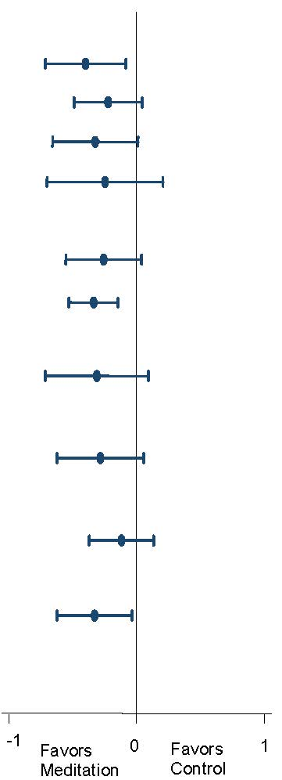
Notes: SOE = Strength of Evidence; PO = Number of trials in which this was a primary outcome for the trial; PA = Primary Analysis;
MA = Meta-analysis; CSM = Clinically Standardized Meditation, a mantra meditation program; TM=Transcendental Meditation, a mantra meditation program; CHF = Congestive Heart Failure; CA = Cancer; CAD = Coronary Artery Disease
Meta-analysis figure shows Cohen’s d with the 95% CI
*Summary effect size not shown due to concern for publication bias for this outcome
**We did not perform meta-analysis on this outcome since it would duplicate the anxiety meta-analysis for mantra. Two additional trials could be added (on depression) but did not have usable data that could be added to the anxiety meta-analysis. Anxiety and depression are indirect measures of negative affect, and therefore resulted in a lower strength of evidence than for the outcome of mantra on anxiety.
+Negative affect combines the outcomes of anxiety, depression, stress/distress, and is thus duplicative of those outcomes

