Figure B1. Summary across measurement domains of comparisons of meditation with nonspecific active controls
[See combined legend for Figures B1 and B2 following the figures for further information, including explanations of symbols and definitions of lettered footnotes]
Outcome | Meditation Program | Population | Directionª (Magnitude^{b}) of Effect | Number of Trials—  Total [PO]: PA (MA);^{c} Total N | SOE^{d}
Anxiety (KQ1) | Mindfulness | Various | ↑ (0% to +44%) | 7 [3]: 6 (6); N = 558 | Moderate for ↑
 | Mantra | Various | Ø (−3% to +6%) | 3 [2]: 3 (3); N = 237 | Low for Ø
Depression (KQ1) | Mindfulness | Various | ↑ (0% to +52%) | 9 [4]: 8 (8); N = 768 | Moderate for ↑
 | Mantra | Various | ↑↓ (−19% to +46%) | 4 [1]: 4 (2); N = 420 | Insufficient
Stress/Distress (KQ1) | Mindfulness | Various | ↑ (+1% to +21%) | 8 [3]: 6 (6*); N = 697 | Low for ↑
 | Mantra | Selected | Ø (−6% to +1%) | 3 [1]: 3 (2); N = 219 | Low for Ø
Negative Affect (KQ1) | Mindfulness | Various | ↑ (0% to +44%) | 13 [5]:11 (11**); N = 1,102 | Low for ↑
 | Mantra | Various | ↑↓ (−3% to +46%) | 5 [2]: 5 (0***); N = 438 | Insufficient
Positive Affect (KQ1) | Mindfulness | Various | ↑ (+1% to +55%) | 3 [0]: 3 (3); N = 255 | Insufficient
 | TM (mantra) | CHF | Ø (+2%) | 1 [0]: 1 (0); N = 23 | Insufficient
Quality of Life (KQ1) | Mindfulness | Various | ↑ (+5% to +28%) | 4 [2]: 4 (3); N = 346 | Low for ↑
Attention (KQ2) | Mindfulness | Caregivers | ↑ (+15% to +81%) | 1 [0]: 1 (0); N = 21 | Insufficient
Sleep (KQ3) | Mindfulness | Various | ↑↓ (−3% to +24%) | 4 [1]: 3 (3); N = 451 | Insufficient
Substance Use (KQ3) | TM (mantra) | CAD | Ø | 1 [2]: 0 (0); N = 201 | Insufficient
Pain (KQ4) | Mindfulness | Selected | ↑ (+5% to +31%) | 4 [2]: 4 (4); N = 341 | Moderate for ↑
 | TM (mantra) | CHF | Ø (−2%) | 1 [2]: 1 (0); N = 23 | Low for Ø
Weight (KQ4) | TM (mantra) | Selected | Ø (−1% to +2%) | 3 [0]: 2 (0); N = 297 | Low for Ø

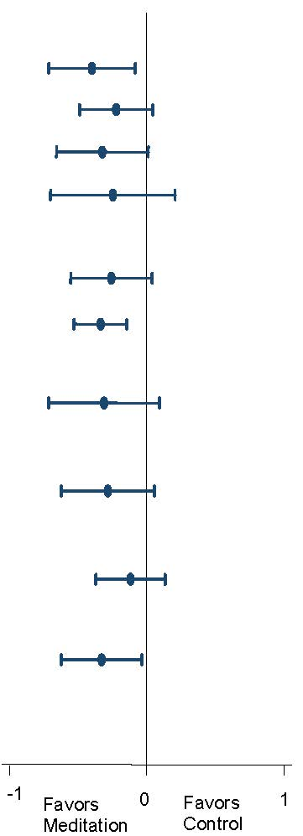
CAD = coronary artery disease; CHF = congestive heart failure; KQ = Key Question; MA = meta-analysis; PA = primary analysis;
PO = number of trials in which this was a primary outcome for the trial; SOE = strength of evidence; TM = transcendental meditation
Meta-analysis figure shows Cohen’s d with the 95% confidence interval.
* Summary effect size not shown due to concern about publication bias for this outcome.
**Negative affect combines the outcomes of anxiety, depression, and stress/distress, and is thus duplicative of those outcomes.
***We did not perform meta-analysis on this outcome, since it would duplicate the anxiety meta-analysis for mantra. Two additional trials could be added (on depression) but did not have usable data that could be added to the anxiety meta-analysis. Anxiety and depression are indirect measures of negative affect, and therefore resulted in a lower strength of evidence than for the outcome of mantra on anxiety.

