Cardiac Resynchronization Therapy and Implantable Cardiac Defibrillators in Left Ventricular Systolic Dysfunction (AHRQ Report Number 152)
Source: Figure 15. Metagraph of all-cause mortality: ICD alone (page 157) [only 9 of 11 studies]
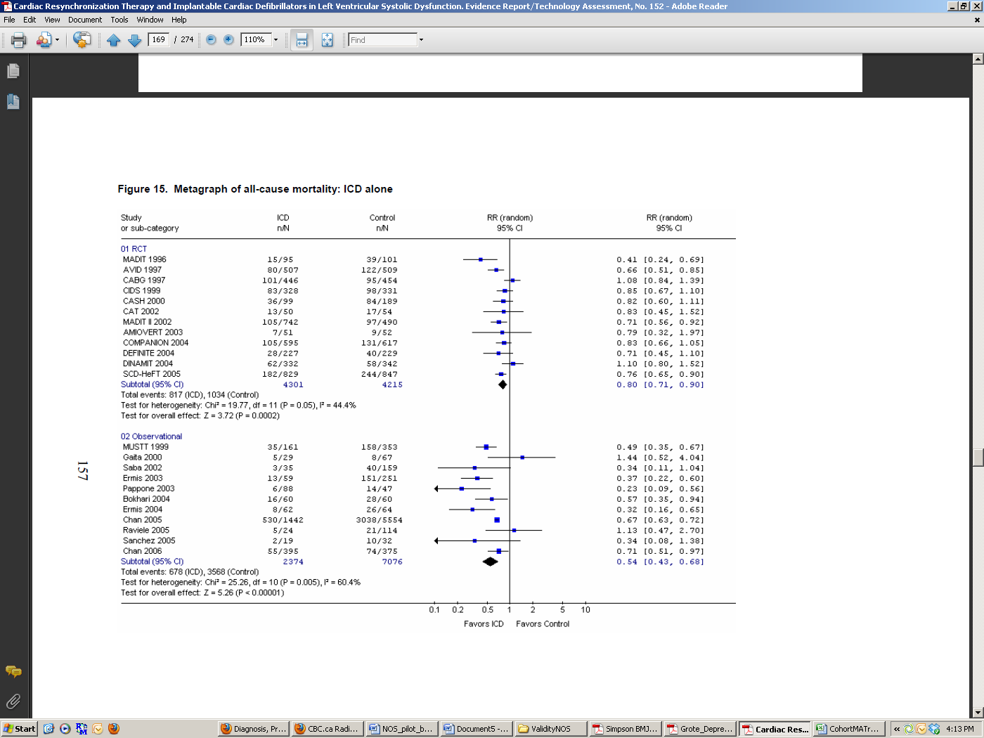
Key Question: In adult patients with symptomatic or asymptomatic left ventricular (LV) systolic dysfunction, what is the efficacy and effectiveness of cardiac resynchronization therapy (CRT) alone, implantable cardiac defibrillators (ICD) alone, or combined CRT-ICD devices compared to usual medical therapy? What is the efficacy and effectiveness of single-chamber ICD compared to that of dual-chamber ICD? How safe is CRT alone, ICD alone, or combined CRT-ICD devices? Which patients would benefit from ICD alone, CRT alone, or combined CRT-ICD devices?
Primary Outcome:
-all cause mortality
Population:
-patients with asymptomatic LV systolic dysfunction or symptomatic heart failure (HF) and left ventricular ejection fraction (LVEF) ≤ 35%
-since the implantation procedure can only be performed in specialized centers, review authors determined that all facilities were representative of patients in usual practice
Comparability:
-NYHA class
-age, sex, race, etiology of heart failure (e.g., ischemic), LVEF, QRS width, rhythm (normal sinus rhythm, atrial fibrillation), medication use
Followup:
-minimum duration of followup: 1 year (12 months)

Adequacy of followup:
≥80% considered adequate

