Grade 5 Social Studies 2015
Paper 2`
MARKS: 20
SECTION A
ANSWER ALL QUESTIONS IN THIS SECTION
Question 1
- State one use of cardinal points
- ________________________________________________________________________ [1]

- Complete the diagram below using inter – cardinal points (write in full)
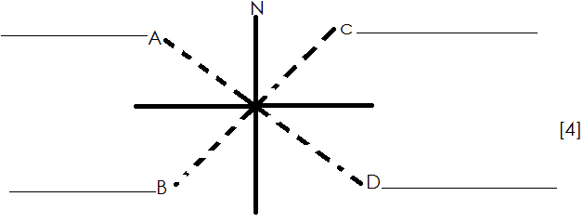

- Name map used to show the following:
- Towns_________________________________________________________________
- rivers___________________________________________________________________
[2]

- In which region is your school located?
- ______________________________________________________________________________________________________________________________________________
[1]

- What is the difference between an inland and an island country?
- ________________________________________________________________________________________________________________________________________________
[2]

Question 2
- What is climate?
- ________________________________________________________________________ [1]

- Name the biggest country in Africa
- _______________________________________________________________________
[1]

- Match the following
Region | Examples of countries
- Northern Africa | Cameroon
- Western Africa | Nigeria
- Eastern Africa | Lesotho
- Central Africa | Tunisia
- Southern Africa | Kenya
[5]

- What is Butimba?
- ________________________________________________________________________________________________________________________________________________
[1]

- Who takes part in doing Butimba?
- ________________________________________________________________________
[1]

- Why is the kraal of the Maasai made out of thorny branches?
- _______________________________________________________________________
[1]

Question 3
Write true or false

- The Portuguese went to India to buy spices
- ________________________________________________________________________ [1]

- Children have the highest authority at home
- _______________________________________________________________________
[1]

- The minister of education is Phineas Magagula
- ________________________________________________________________________
[1]

- Incwala ceremony is mainly for women?
- ________________________________________________________________________
[1]

- The queen mother of Swaziland is Queen Labotsibeni
- _______________________________________________________________________
[1]

Question 4

- Complete the following table.

Kinds of transport | examples
- Road
 | Ship
 | Train
- Air
[4]

- Which kind of transport would you use to transport coal from Swaziland to Mozambique?
- ______________________________________________________________________
[1]

- Give examples of technology used in:
- baking________________________________________________________________
- communication_______________________________________________________
[2]

- on a street map, what do the following abbreviations stand for:
- St______________________________________________________________________
- Rd_____________________________________________________________________
[2]

- In which country is the Kgalagadi desert?
- ______________________________________________________________________
[1]

Question 5

- Complete the table below:

Country | Capital city
- Lesotho
- South Africa
 | Mbabane
- Zambia
 | Harare
[5]

- What names were given to San by:
- Swazis_______________________________________________________________
- Batswana___________________________________________________________
[2]

- Describe the shelter of the San
- ________________________________________________________________________________________________________________________________________________
[1]

- Name one animal kept by the livestock
- ________________________________________________________________________
[1]

