GRADE 7 SCIENCE PAPER 1
TIME: | HRS

TOTAL MARKS: | 40

PUPIL’S NAME:

PUPIL’S INSTRUCTIONS:
- Answer all questions
- Circle the correct answer
- Write neatly and legibly

- To state of matter does frozen water belong
- Air
- Gas
- Liquid
- Solid

- Which gas is used by plants to make their own food
- Nitrogen
- Carbon dioxide
- Oxygen
- Hydrogen

- Which of the following is a non-living thing
- Gum tree
- Cat
- Cow
- Book

- What is the definition of volume?
- Amount of matter in an object
- Amount of space occupied by an object
- Mass of a substance per unit volume
- Measure of hot or cold a substance is

- Which behavior could put a person at risk of contracting stis?
- Having unprotected sex
- Sleeping with a friends
- Having many friends
- Being too fond for sex

- The diagram below show the digestive system, use the diagram to answer questions 6 and 7

What is the name of the part labelled Z?
- Mouth
- Gullet
- Stomach
- Rectum

- Which part is responsible for the absorption of digested food into the blood stream?
- W
- X
- Y
- Z

- Which planet is closest to the sun?
- Earth
- Jupiter
- Pluto
- Venus

- Which part of a plant is used by non-flowering plants to reproduce?
- Fruit
- Seeds
- Stem
- Stigma

- The diagram shows a box that was used to store salt
8 cm
3 cm
4 cm

Calculate the volume of the box
- 15cm
- 44cm
- 56cm
- 96cm

- Which of the following is not a condition for seed germination?
- Air
- Moisture
- Soil
- Warmth

- The diagram shows four different animals

Which letter G,H,I, or J represent a reptile?
- G
- H
- I
- J

- Which statement describes seed dispersal?
- Spread of seeds from the parent plant
- Spread of pollen from the flower
- Transfer of nectar from the nectary
- Growth of a plant from a seed

- Sipho has bleeding gums, which nutrient would be lacking in his diet?
- Calcium
- Iron
- Vitamin A
- Vitamin C

- Musa hangs his clothes outside on a sunny day. What is the name of the process that takes place on the clothes to help the dry up?
- Condensation
- Evaporation
- Melting
- Solidification

- The diagram shows parts used for breathing in human

What happens to the air when it enters the lungs?
- Oxygen is absorbed by the blood
- Carbon dioxide is stored in the lungs
- Oxygen is sent through the nose
- Carbon dioxide is absorbed by the lungs

- Which of this helps to send and receive impulses from the brain?
- Muscles
- Nerves
- Skin
- Stimulus

- Animals that eat both plant and animals are called………..
- Herbivores
- Carnivores
- Omnivores
- Herbivores and carnivores

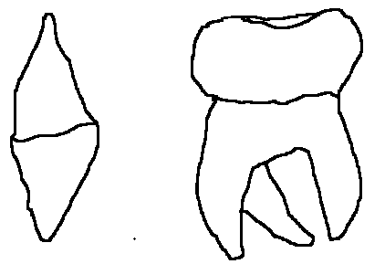
- The diagram shows two types of teeth
E
F

What are the names of the teeth?
 | E | F
A | Canine | Molar
B | Incisor | Molar
C | Molar | Canine
D | Molar | Incisor

- Which of these substances is alkaline?
- Orange juice
- Soft drink
- Sour milk
- Toothpaste

- Which of the following organisms causes AIDS?
- Bacterium
- Fungus
- Germs
- HIV

- Muzi planted his bean seed for his school experiment in a clear container. He observed the bean as it germinate and drew it to look like the one in the diagram below

Which parts of the bean grow to a root and shoot after germination?
- I and II
- I and III
- Ii and III
- II and IV

- What would you use to taste of a substance is alkaline
- Baking soda
- Filter paper
- Lime water
- Litmus paper

- The diagram shows nonhlanhla’s drawing after an experiment with a bar magnet and iron fillings
State what the lines around the bar magnet represent

- Magnetic force
- Magnetic lines
- Magnetic field
- Magnetic poles

- Which of these item is a group of magnetic objects?
- Wool, paper clips and rubber
- Paper, plastic and spoon
- Steel wool, pencil and battery
- Nails, iron and pins

- What do the letters STI stand for?
- Sexually Transmitted Disease
- Sexually Transmitted Infection
- Sexually Transmitted Influence
- Sexually transmitted Illness

- What keeps blood moving through the body in human beings?
- Blood vessels
- Heart
- Muscles
- Pulse

- Which movement of the earth results to the four seasons of the year?
- Evolution
- Orbiting
- Revolution
- Rotation

- Which of these are required by plant to make their own food?
- Carbon dioxide and water
- Chlorophyll and oxygen
- Chlorophyll and hydrogen
- Water and oxygen

- Which of these are bad effects of weather?
- Drought, floods, and tornados
- Drought, pests and hunger
- Hunger, poverty and diseases
- Hurricanes, storm and poverty

- What is the energy conversation in a solar panel?
- Chemical into electrical
- Electrical into chemical
- Heat into sound
- Kinetic into potential

- Which eclipse is represented by the diagram below
moon
earth
sun

- Eclipse of the moon
- Eclipse of the sun
- Ecliptic sun
- Ecliptic moon

- Yazi noticed lines of beautiful colours of the sky after it had rained, what do you think yazi saw?
- Clouds
- Light
- Rainbow
- Lightening

- The diagram shows a magnet

What is the name of the magnet?
- Bar
- Compass
- Cylinder
- Horseshoe
- The diagram below shows water being transported in a plant from the soil, use the diagram to answer questions 35 and 36
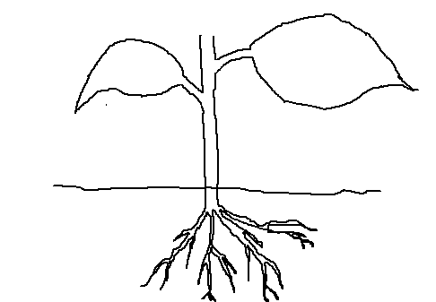

Name the part of the plant that absorb water and mineral salts from the soil
- Large roots
- Root cap
- Root hair
- Root ends

- What happens to too much water when it reaches the leaves?
- Becomes vapour and cools down the leaves
- Becomes vapour and escapes to the atmosphere
- Becomes vapour and used in respiration
- Always flow out of the leave at night as a liquid

- Which of this is not a function of the skin
- Feelings
- Protecting
- Sweating
- Urinating

- Worms are supported by body fluids, what support vertebrates?
- Joints
- Body organs
- Long bones
- Skeleton

- One of this solid is soluble in water
- Stone
- Meali meal
- Sugar
- Nails

- Which one is an artificial source of light?
- Stars
- Candle
- Sun
- Moon

GRADE 7 SCIENCE PAPER 1 MARKING GUDE

- D
- B
- D
- B
- A
- C
- C
- D
- C
- D
- C
- C
- A
- D
- B
- A
- B
- C
- A
- D
- D
- A
- D
- A
- D
- B
- B
- C
- A
- C
- A
- A
- C
- A
- C
- B
- D
- D
- C
- B

