GRADE 6 SCIENCE PAPER 2 MOCK EXAMINATION 2015

NAME:

SECTION A (1-5) ANSWER ALL QUESTIONS IN THIS SECTION

QUESTION 1
a) What are vertebrates?
_______________________________________________________________________ (1)
b) Give the five classes of vertebrates, giving one example in each.
(i)_____________________________________________________________________
(ii)_____________________________________________________________________
(iii)_____________________________________________________________________
(iv)_____________________________________________________________________
(v)______________________________________________________________________ (5)
c) Invertebrates are animas without backbones, for example arachnids. Give the characteristics of arachnids.
(i)_______________________________________________________________________
(ii)_______________________________________________________________________
(iii)_______________________________________________________________________
(3)
d) One of the following is an example of a hard-bodied animal_______________
Locust, crab, tick, mite (1)
[10]

QUESTION 2
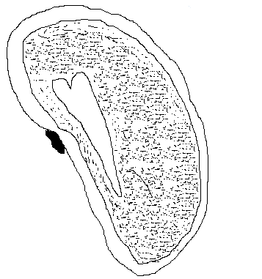
a) Label the parts of the bean seed. (5)
(I)
(V)
(II)
(III)
(IV)

b) Give the functions of the following:
(i) Plumule___________________________________________________________________
(ii) Radicle___________________________________________________________________
(2)
c) State the three conditions necessary for seeds to germinate
(i)___________________________________________________________________________
(ii)___________________________________________________________________________
(iii)___________________________________________________________________________
(3)
[10]
QUESTION 3
a) What is Transpiration? (2)
____________________________________________________________________________________________________________________________________________________________
b) Lolo tied a transparent plastic bag around a branch with a piece of string tight enough to remain in one position and not to allow air in or out over night.
(i) What would Lolo observe in the plastic the following day?___________________ ___________________________________________________________________________(1)
(ii) Where does the water in the plastic bag comes from?______________________
___________________________________________________________________________(1)
c) Leaves have tiny holes or pores, what name is given to this holes?____________ ___________________________________________________________________________(1)
d) State one factor affecting transpiration in plants under the following topics
(i) Environmental_____________________________________________________________
(ii) Leaf fetures_______________________________________________________________
(2)
e) State three important of response to stimuli in plants.
(i)___________________________________________________________________________
(ii)___________________________________________________________________________
(iii)___________________________________________________________________________
(3)
[10]
QUESTION 4
a) What is Volume?___________________________________________________________
___________________________________________________________________________(1)
b) Give two any units of volume
(i)____________________________
(ii)____________________________ (2)
c) Calculate the volume of a regular box with the following measurements:
length 6cm, width 2cm, height 1cm
_______________________________________________________________________________________________________________________________________________________________________________________________________________________________________(2)
d) Sifiso, a grade 6 pupil at st paul’s primary poured water in a measuring cylinder measuring 308ml. he tied a stone with a string and gentle lower the stone into the water in the measuring cylinder until it rest at the bottom of the cylinder. The level of the water rose to 437ml.
(i) calculate the volume of the stone?

_________(1)
(ii) why is it important for Sifiso to gentle lower the stone?______________________
___________________________________________________________________________(1)
e) explain how you can use an overflow can to measure the volume of an irregular object (stone) _______________________________________________________
_____________________________________________________________________________
___________________________________________________________________________(3)
[10]
QUESTION 5
a) Draw the following types of magnets (3)
(i) Bar magnet

(ii) Horse shoe magnet

(iii) Cylindrical magnet

b) Study the diagram below and answer the questions that follow:

(i) Which part of the magnet attracts iron filings with the greatest force? ________
___________________________________________________________________________________(1)
(ii) Which part of the magnet attracts iron filings with the least force?____________
___________________________________________________________________________(1)
(iii) what name is given to the space around a magnet where its magnetic force is felt?_____________________________________________________________________(1)
c) Similo dropped a magnet by mistake upon picking it up, he realized that it does not attract magnetic materials.
(i) Explain what has happened to the magnet?________________________________
___________________________________________________________________________(2)
(ii) How else can a magnet be destroyed ?____________________________________
______________________________________________________________________________
______________________________________________________________________________
__________________________________________________________________________(10)

SECTION B
1. ANSWER ANY ONE QUESTION OF YOUR CHOICE IN THIS SECTION
2. READ THE QUESTION CAREFULLY BEFORE YOU MAKE YOUR CHOICE

- Define the solar system_________________________________________________
_____________________________________________________________________(2)
- How many planets are there in the solar system?______________________(1)
- Which planet is closest to the sun?____________________________________(1)
- Pluto is the coldest planet in the solar system. Explain why it is the coldest?_____________________________________________________________(1)
- Each planet moves around the sun. give the name of the path it follows _____________________________________________________________________(1)
- Rotation is the spinning or the earth on its axis, state the results of the rotation of the earth __________________________________________________
_____________________________________________________________________(1)
- Explain why we can not feel the movement of the earth on its axis. ______
_____________________________________________________________________(1)
- State any two safety precaution measures you learned about the sun ____
(i)______________________________________________________________________
(ii)_____________________________________________________________________
(2)
[10]
QUESTION 7
- Label the eclipse below
(i)

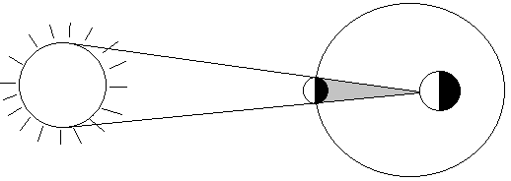
Sun
Earth
Moon
Moon’s shadow

________________________________________________(2)
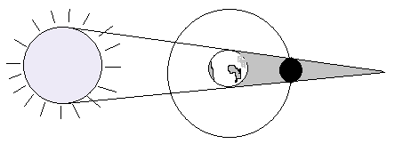
(ii)
Sun
Earth’s shadow
Earth
Moon

____________________________________________________(2)

- What is an eclipse? ____________________________________________________
_____________________________________________________________________(2)
- Swaziland once experienced an eclipse and it was announced through the media, newspaper, radio and television that will be dark during the day,
- When did Swaziland experience the eclipse _______________________
_______________________________________________________________(2)
- Give one warning given to the swazi nation concerning the eclipse
__________________________________________________________________
_______________________________________________________________(2)
[10]

GRADE 6 SCIENCE PAPER 2 MARKING GUIDE

QUESTION 1
- Vertebrates are animals with backbone
- Mammals
Fish
Amphimbians see examples
Reptiles
Birds
- (i) have many eyes, called simples eyes
(ii)Body devided into two parts, upper and bottom
- Have substances similar to feelers
- Crab
QUESTION 2
- (i) plumule
(ii) seedcoat
(iii) cotyledon
- radicle
- hilum
- (i)develop into the shoot
(ii)grows downwards and develop into the root
- (i)moisture
(ii)air(oxygen)
(iii)warmth
QUESTION 3
- Process by which plants lose water vapour to the atmosphere
- (i)water droplets/ water vapour
(ii)plant/leaves
- Stomata
- (i)sunny, cloudy or windy
(ii)leaf size, thorny, shinny, hairy or thickness
- Need for food, need for light, search for water, protects themselves from danger
QUESTION 4

- Amount of space an object occupies
- Cm^3, m^3, ml
- 6cm x 2cm x1cm x = 12cm^3
- (i)437ml
-308ml
129ml
(ii)to make sure that no water is split from cylinder
- (i)put the over flow can on the surface and fill it with water allowing the water to spill until it stops
(ii)put the measuring cylinder under the spout of the overflow can and gentle lower the stone into the water in the overflow can wait for it to stop spilling
(iii)read the volume of water in the measuring cylinder
QUESTION5
- (i)
S | N

(ii)
N

S

(iii)
S | N

- (i) poles/north and south poles
(ii) middle
(iii) magnetic field
- (i) has lost its magnetic force
(ii) heating and hummering
QUESTION 6
- The sun and planets
- 9
- Mecury
- Furthest from the sun
- Orbit
- Day and night
- It is so large and the movement is so steady
- (i) do not directly to the sun
(ii) do not expose your body to the sun
QUESTION 7
- (i) solar eclipse
(ii) lunar eclipse
- When the sun, moon and earth are in straight line
- (i) 21 june 2001
(ii) do not look at the eyes with naked eyes

