**Grade 1 Religious Education 2015**

**Mock Exam**

**Section A**

On which day God created these things. **Write the number.**

1. ...

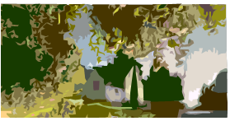

**LAKE or River**

1. …

C:\Program Files\Microsoft Office\MEDIA\CAGCAT10\j0149627.wmfC:\Program Files\Microsoft Office\MEDIA\CAGCAT10\j0332364.wmf

1. …





 [5]

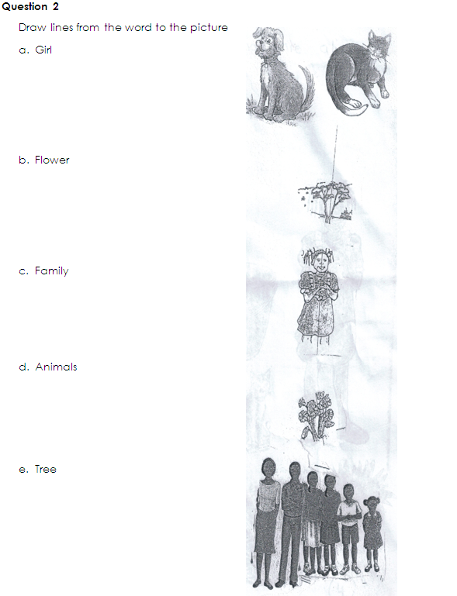

[5]

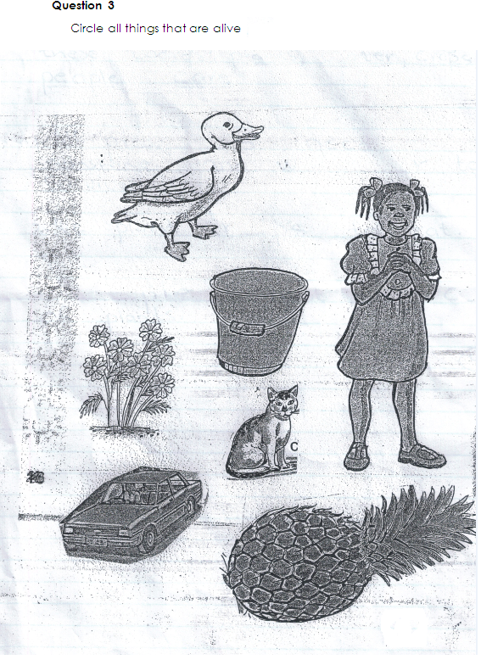

[4]

**Question 4**

Complete the sentences using these words:

**Plants Water Crops People care**

1. All pl____ ______ ______s need sunshine and w _____ ______ _____r to survive.
2. We plant cr ______ps to eat.
3. P_____ ______ ple must take c_____ _____e of plants

[4]

**Question 5**

Make a tick **(√)** next to the animals that lives at home. Make a cross **(x)** next to the animals that do not live at home.

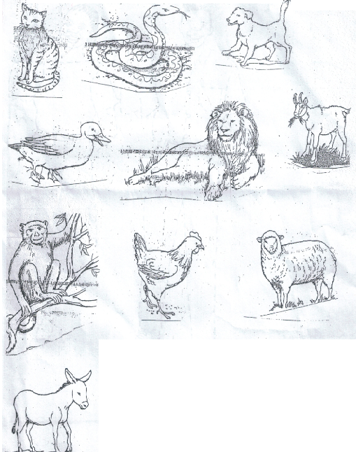

[10]

Join the dotted lines and colour in the picture of a woman and a man

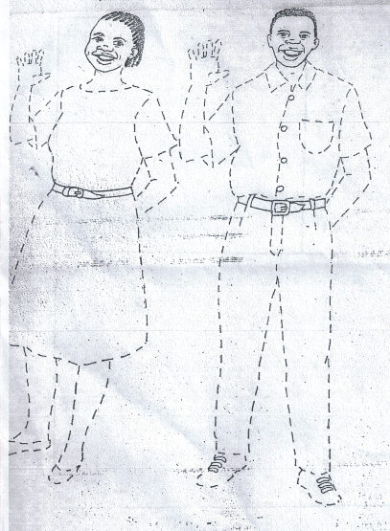

[6]

Draw the **moon**, **stars** and the **sun** and colour them

|  |  |
| --- | --- |
|  |  |
| |  | | --- | |  | | |

[6]

**Total – 40 Marks**