Grade 7 Mathematics 2015
Mock Examination
Marks: 60
Paper 1
Instructions
- Answer all questions
- Show all necessary working on this sheet
- This paper has two sections. Section A has 20 multiple choice questions
- In section A cross (×) the correct option only on the answer grid provided.

Section A

- 56.2
- 362.068
- 362.68
- 36 268

- Millions
- Hundred thousand
- Ten thousand
- Thousands

- 485 000
- 485 700
- 486 000
- 500 000

- i)
- ii)
- iii)
- iv)

Question 1
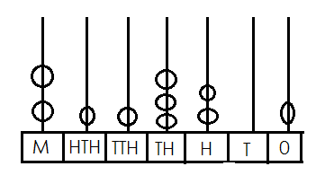
- What is the number shown by the abacus?

Question 2
What is the place value of the 4 in the number 5 349 265?

Question 3
What is 485 729 rounded to the nearest thousand?

Question 4
Which is the correct expanded form for 708 401?
- 7 000 000 + 800 000 + 400 + 1
- 7 000 000 + 80 000 + 4 000 + 1
- 7 000 000 + 80 000 + 400 + 1
- 7 000 000 + 8 000 + 400 + 1
Question 5

- 6.15
- 7.05
- 7.72
- 7.68

- 10 914 300
- 11 573 145
- 18 138 744
- 24 727 194

- 8:54 am
- 0854hours
- 0911 hours
- 1145hours

- 12102
- 1 212 rem 1
- 12 012 rem 1
- 12 102 rem 1

- 2/4
- 2/8
- 1/32
- 2/12

The difference of 10.7 and 3.02 is…

Question 6
The sum of these numbers.
73 205, 1 834 071, 729 511 and 8 277 513

Question 7
The time on this clock face in 24 hour time in the morning is_____

Question 8
Divide 278 347 ÷ 25

Question 9
Work out the following
1/8 × ¼

Question 10
- 23%
- 30%
- 70%
- 333%

- 2/4 pupils
- 2 1/8 pupils
- 4 pupils
- 16 pupils

- 7/12
- 2/7
- 2
- 1

- 8. 718
- 87.18
- 871.8
- 8718.00

- 2
- 6
- 24
- 32

What percentage is E18 000 of E60 000.

Question 11
Mandla has 2 full cakes and he has to share it among his friends, each
Person gets 1/8 of the cake. How many pupils will get this cake?

Question 12.
Work out
2 1/3 × ¼

Question 13
A tin of fish costs E14.53, how much would Sipho pay for 6 tin of fish?

Question 14
A bus takes 3hrs to travel 4km from pig’s peak to Mbabane. How many
Hrs. will it take to travel for 8km

Question 15
In a money lender business they charge 20% interest for borrowing
Money. Calculate the interest of borrowing E13 500.00
- E2 700
- E 27.00
- E270.00
- E162 000

- 1 2/8
- 96/8
- 12
- 96

- 0.505cm
- 5.05cm
- 505cm
- 5050cm

- 11.5203
- 115.203
- 1152.03
- 11520.3

- 2
- 7
- 9
- 63

Question 16
Calculate:
12 ÷ 1/8

Question 17
A pile of 100 bricks of equal thickness is 50.5cm high.
Find the thickness of each brick

Question 18
Divide
13 824.36 by 12

Question 19
Work out
63 ÷ (7+2) – 12 ÷ 3

Question 20
- E2 700
- E 27.00
- E270.00
- E162 000

Find the volume of the figure
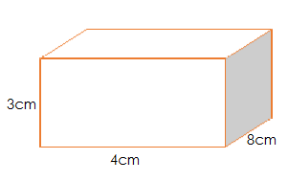

[40 Marks]

Section B

- __________________[3]

- ____________________[3]

- ____________________[3]

Question 21
A. Write the values in that make the statement below to be true.
6 × (5×7) = (6 × [ ]) × [ ] = [ ]
B. use the number line below to show
2 + (4 + 3) = (2 + 4) + 3

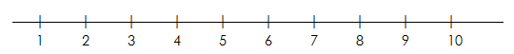

[4]
Question 22
Draw line to match the following
- Odd numbers 3, 6, 9, 12, 15…
- Prime numbers 1,2,3,4,6,8,12,14
- Even numbers 1,3,5,7,9,11,13,15
- Factors of 24 2,3,5,7,11
- Multiples of 3 2,4,6,8,10,12
[5]

Question 23
Work out the following
- 1 ¾ + 2 ½

2 1/3 + 4 2/5

- 7 ¼ - 1 ½

Question 24

- __________________[2]

- __________________[2]

- __________________[3]

- ___________________[3]

- ___________________[3]

- ___________________[3]

- ____________________[3]

- ____________________[3]

Work out
- 6 442 853 + 3 762 036

- 28 745 × 17

- A farmer has some pigs. Each of them eats 20kg of pig meal per
Week. How many pigs does he have if he needs 3 740kg of the
Pig meal per week?

Question 25
A cool drink bottle holds 3/10 litres. How many litres of cool drinks
would be contained in 15 bottles?

Question 26
Copy the following numbers and arrange them in order starting with the
Smallest.
0.236, 0.352, 0.253, 0.325

B. write 0.75 as a common fraction in its simplest form.

Question 27

- ___________________[3]

- ___________________[3]

- ___________________[3]

LaMaseko bought a hand bag at a factory shop in Durban for E200
She sold it to LaNgozo for E350
- How much profit did she make?

- What was the percentage profit?

Question 28
Work out:
Year Months
+ 8 7
2 9
___________________________

Question 29
If a triangle PQR is an isosceles triangle with PQ=PR, find the size of
An angle RPQ (not drawn to scale)
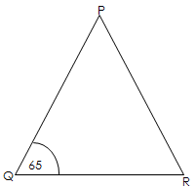

Question 30

- _________________[2]

- ________________[1]
- ________________[2]

- ___________________[2]

C _____________________[2]
D. ________________________[2]

Work out:
27.1 – 2.32

Question 31
Mr Mavundla has a total of 180 animals. There are twice as many goats
As sheep. The information is represented in the pie chart below.

- ..
- Which of the animals are fewer in number?
- How many of these animals are there?

- What fractions of the animals are goats?

- What is the sector angle for the sheep?

- Write the sector angle for the sheep as percentage

