Grade 7 Mathematics 2015
Mock Examination
Marks: 100
Paper 2
Instructions
- Answer all questions in this paper
- All working must be shown. It should be done on the same sheet.

NAME _________________________________________________________________

For office use | Score

No: 1

- ________________[1]

- ______________________________________________________[2]

- ___________________________________[2]

- ________________[1]

Use this number 9 356 478 to do the following:
- Write down the place value of 3 in the number above

- Write the above number in words

- Write the above number in expanded form

- Round it to the nearest ten thousand

- Draw spike abacus and show the number above on the spike abacus

No: 2
Sphelele bought a toy that cost E19.95. She paid with a E20 note. What is the smallest number of coins she can get as change?
Rewrite the same problem in your own words.
- ________________________________________
________________________________________
________________________________________
________________________________________

No: 3
Mr Moyo is a farmer, he has 12 cows for milking, and he gets
12.3L per cow in a day
- How much milk does he get per day altogether?

- ________________[2]

- _______________L[2]

- _______________E [3]

- ________________ [2]

- ________________ [3]

- How much milk will he get in a month?

- If he sells 3/5 of the total amount of milk he gets in a
month, at E8.05. Calculate the total money he gets
from selling the milk

No: 4
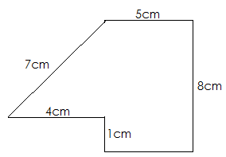
- Find the perimeter f this shape

- Calculate the area of the above shape

No: 6

- __________________[3]

- ________________[3]

- ________________[2]

- ________________[3]
The population has 50L container and he has to fill it with water
Using a cup that is 250ml. Find out how many such cups will he
Need to fill up the container

No: 6
The population of four countries is as follows:
Malawi: 18 307 596 Swaziland: 1 893 078
Lesotho: 7 805 007 Namibia: 13 975 669
- Find the total population for all four countries

- By how many people is the population of Namibia bigger
than that of Swaziland

No: 7
- How many squares are in this figure?

No: 8

a__________________[2]

b. ___________________ [3]

- ____________________[1]

- ____________________[3]

- ___________________________________[2]

Sipho usually leaves home for school at 6:15am and come back home at
3:45pm. His school start at 7:45am and ends at 2:15pm

- Write the time Sipho leaves home for school in the 24hr clock.

- How long is Sipho away from home?

- In Sipho’s school they have a break for 30minutes at 10:45am
To __________________am

- if Sipho leaves school at 2:50pm, how long does it take him to
reach home?

No: 9
Find the quotient of these two numbers 8 261 326 and 46

No: 10
- Mr Mavundla build a house with 509 blocks, each block cost
E4.69 in the block yard. The builder charges him E2 350.00,
The other building material cost him E18 400.00 to complete
the house. His income comes from machines, 1 car cost E8.250
for 5 cars

- ________________[3]

- ________________[3]

a__________________ [4]

- ___________________ [1]

- ____________________[1]

- ____________________[3]

- ____________________[3]

- Calculate the cost of all the blocks

- How much income will he make from the 5cars?

- find his total expenditure

- ________________[2]

- ________________[2]

a__________________ [3]

- ___________________[3]

- _______________________[2]

- Calculate his savings

No: 11
Show the spreading property of:
12× (12+10) =

No: 12
Mrs Lukhele borrowed a sum of E25 000.00 in a bank to start business
The Bank charges 13% per annum (per year)
- How much is Mrs Lukhele’s interest charged?

- How much money will she pay back at the bank?
No: 14

- ____________________[2]
Hint: 1 area = 100m² and 1 hectare = 100 areas

Find out how many square metres is 1800 hectares?

No: 15
Complete the tessellation below cover whole grid

No: 16

- ____________________[2]

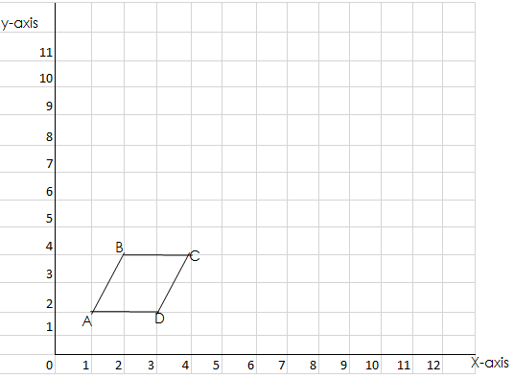

- Draw the image after reflection in the line x=6 label it
JKLM respectively [3]

- Slide the figure ABCD on 25q right and 45q up then draw
And label image A’B’C’D’ [3]

- Enlarge A’B’C’D’ using scale factor 2 with A’ as the centre
Of enlargement and label it image T U V W

- Find the perimeter of T U V W assuming that 15q is 1cm
by 1cm

No: 17

- ____________[2]

Bongiwe has 36 sweets in all. ½ g them are stumbos, 4 are smoothes,
6 are chappies and the rest chocolate.
- ….

- Calculate the angle sector for all the different types of

Sweets Bongiwe has.

- Draw a pie chart to represent the information above.

