**Grade 6 Mathematics 2015**

**Mock Examination**

**Marks: 100**

**Paper 2**

**Instructions**

1. Answer all questions in this paper
2. All working must be shown. It should be done on the same sheet.

**NAME _________________________________________________________________**

|  |  |
| --- | --- |
| **For office use** | **Score** |
|  |  |

**No: 1**

1. ________________[1]
2. ______________________________________________________[2]
3. ___________________________________[2]
4. ________________[1]
5. __________________[1]
6. ______________________________________________________________________________________________________________[2]
7. ____________________[2]

State whether the following statements are **true (T)** or **false (F)**

1. The distance between Manzini and Nhlangano is about 132km.
2. The height of a newly born baby is about 1m
3. 2,8,10 are even numbers
4. The volume of water in cup is 250g
5. 3 and 9 are prime numbers

**No: 2**

1. What is the value of 3 in this number 375 982?
2. Write the number 652 463 in words
3. Write the above number in 2(b) in expanded form

**No: 3 Work out**

1. ________________[2]
2. ________________[2]
3. ________________[2]
4. ________________[1]
5. ________________[2]
6. 2/3 + 3/5
7. 2 1/6 + 4 2/3
8. 5 ½ - 2 2/6

**No: 4**

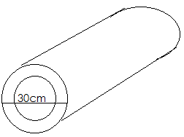

1. What is the radius of the pipe?
2. What will be the circumference of the pipe?

**No: 5**

1. ________________[3]
2. _______________[3]
3. ________________[1]
4. ________________[3]
5. Samkeliso cuts a 460m rope into equal lengths of 5m each
6. How many pieces of 5m rope does she get?
7. Musa used 36.9 litres of water for bathing in August.

In the same month, Zinhle used 296.93nlitres. How much

Water was used by the two children in August?

**No: 6**

Muhle tours on a certain Monday left Nhlangano to Mbabane at 9:27 am

Classic bus service left Nhlangano 38minutes earlier than Muhle tours.

1. Write Muhle tours’s time of departure in 24HR time
2. At what time did classic bus service leave Nhlangano

**No: 7**

1. Use a compass, ruler, pencil to construct triangle FDS with

FD = DS =FS =5cm [5]

1. What name is given to triangle FDS?

b. ______________________ [1]

c. ________________________ [2]

1. ___________________[1]
2. ___________________[1]
3. Mrs nkosi_________[2]

Mrs maroena _______[2]

1. __________________[2]
2. ________________[2]
3. How many degrees will be each angle?

**No: 8**

How many lines of symmetry does each figure have?

**No: 9**

Two women, Mrs Nkosi and Mrs Moreona work in one of the

Wholesalers in Manzini. Mrs Nkosi earns E550 per week, Mrs Moreon

Earns E400 in a fourthnight

1. How much does each woman earn in month?
2. What is mrs Nkhosi’s annual pay?

**No: 10**

Find the missing angles

1. 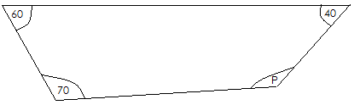
2. 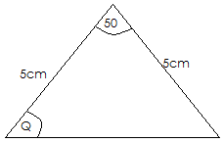

ii) Q______________________[2]

1. __________________[1]
2. __________________[1]
3. __________________[1]
4. Draw an angle that is 270° [2]

**No: 11**

The Figure below is made of 4 straight lines

PQ, RS, TU and VW

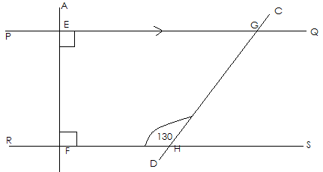

In this figure above name:

1. The line parallel to PQ
2. The line perpendicular to PQ
3. the angle HGQ

**No: 12**

1. ________________[3]
2. ________________[3]
3. __________________[3]
4. ___________________[3]

Study the shapes below and calculate their area.

1. 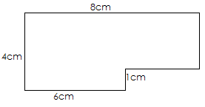

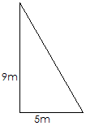

**No: 13**

To find Mr Dlamini’s age, you double Vusie’s and then add.

1. How old is Mr Dlamini if Vusi is 15yrears old?
2. Using the long division method work out 710 333 ÷ 15

**No: 14**

Study this dot patterns carefully

b. ______________________ [1]

c. ______________________ [1]

d. _______________________ [3]

|  |  |  |  |  |
| --- | --- | --- | --- | --- |
| 1st | 2nd | 3rd | 4th | 5th |
|  |  |  |  |  |
| 1 | 3 | 5 | 7 |  |

1. Complete the pattern for the 5th diagram [2]
2. How many dots will be on the 9th diagram?
3. What type of numbers does the dot pattern show?
4. Write down the rule for finding the number of dots for any

postion

**No: 15**

On the grid below write the first numbers horizontal and vertical from

0 to 15 [2]



1. Plot the points and join them

ii) __________________[1]

1. A. ______________[1]

B_______________[1]

C_______________[1]

D_______________[2]

1. A. ______________[1]

B. _____________ [1]

C.______________ [1]

D. _____________ [1]

M(2,2) N(5,5) O(11,5) P(11,2) [3]

1. What special name is given to this quadrilateral? [3]
2. Slide MNOP through 1 square left and 5 squares up and

Name the image M1N1O1P1  [2]

1. On M1N1O1P1 draw all the lines of symmetry [1]

**No: 17**

In a class of 40 pupils they were asked to join the sports they like most.

20 liked soccer, 5 liked netball, 8 liked volleyball and the rest tennis.

1. What fraction of the pupils liked
2. Soccer
3. Netball
4. Volleyball
5. Tennis
6. Calculate the sector angle for pupils who liked:
7. Netball
8. Volleyball
9. Soccer
10. tennis
11. on the space below construct a pie chart to show the above information.