Grade 5 Mathematics 2015
Mock Examination
Marks: 80
Paper 1
Instructions
- Answer all questions
- Show all necessary working on this sheet
- This paper has two sections. Section A has 20 multiple choice questions
- In section A circle (O) the correct option only on the answer grid provided.

Section A

- 20 463
- 63 402
- 63 422
- 64 574

- Tens
- hundreds
- thousands
- ten thousands

- 20 000+1000+900+90+9
- 20000+10000+900+90+9
- 21000+900+90+9
- 21000+9000+90+9

- 43 311
- 70 565
- 71 565
- 715 515

Question 1
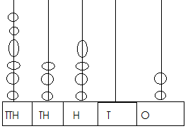
- What is the number shown by the abacus?

Question 2
What is the value of 3 in 63 241

Question 3
The number 21 999 in expanded form is

Question 4
The sum of 57 438 and 14 127 is…

Question 5

- 3
- 6
- 9
- 18

- 20.4
- 20.6
- 22.75
- 23.45

- 5, 10, 15, 20
- 10, 20,25, 30
- 10,15,20,25
- 15,20,25,30

- 1 344
- 3 144
- 4 134
- 4 431

- 2 563
- 25.63
- 2.563
- 0.2563
The HCF of 18 and 30 is

Question 6
What is 23.1 – 0.35

Question 7
The multiples of 5 between 9 and 28

Question 8
What is the product of 48 x 28?

Question 9
Twenty five and sixty three hundredths in numerals is…

Question 10
The fraction of a turn that the minute hand turns through as it moves
From 6 to 9 is

Question 11
What is 85 729 rounded off to the nearest Thousand

Question 12.
The correct symbol to compare the two decimal factions
0.55 [ ] 0.455

Question 13
Choose an obtuse angle below
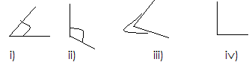

Question 14
How many line of symmetry does the figure have?

- ¾
- 2/4
- ¼
- ½

- 80 000
- 85 700
- 85 720
- 86 000

- >
- <
- =
- ?

- (i)
- (ii)
- (iii)
- (iiii)

- 1
- 2
- 3
- 4

Question 15
Using the scale 1:100 find the distance on the plan if the distance on the
ground is 500cm in metres
- 500m
- 200m
- 50m
- 5m

- 4 pieces
- 5 pieces
- 9 pieces
- 10 pieces

- 1/3
- 1/6
- 2/6
- 3/9

- 0230hrs
- 0203hrs
- 1403hrs
- 1430hrs

- 16/5
- 29/5
- 35/5
- 39/5

Question 16
Choose a quadrilateral below:
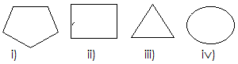

Question 17
What is 6/18 in its simplest form?

Question 18
Write 2:03pm in 24hr time

Question 19
Which roman figure represents 3 1/3 on the number line below?

Question 20
What could be the new number if you removed 2 from the Tens?
8 432

[40 Marks]

- Angle
- Circle
- Sector
- factor

- 8 412
- 8 430
- 8 434
- 8 452

Section B

- ________________[2]

- ________________[3]

b. ____________________ [1]
c. ____________________ [1]
d. ____________________ [2]

Question 21
Match the following using arrows:
- Parallel angle less than 90°
- Acute figure with four sides
- Quadrilateral lines that never meet
- Protractor construct a circle
- Compass to measure angles
[5]
Question 22
- Find the HCF of 24 and 36

- Arrange these decimal fractions starting with the largest
1.5 0.69 1.59 [3]

Question 23
a. Represent 21 364 on the spike abacus below. [1]
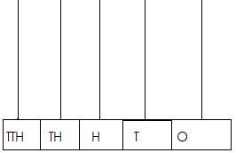
b. Write the number in (a) in expanded form
c. What is the value of 1 in this number?
d. round off this number to the nearest hundred

Question 24
Fill in the blanks spaces
12 Hr. | 24Hr
- 11:05AM
 | 1406Hrs
- 1:45AM
 | 12 midnight
- 12:01PM

Question 25
WORK OUT
- 4 235 x 22

[5]

- __________________[3]

- __________________[3]

- __________________[2]

- __________________[3]

- __________________[4]

- __________________[1]

- 5 344 ÷ 2

Question 26
Write down:
- Odd numbers between 6 and 10

- Even numbers between 15 and 21

- Prime numbers between 10 and 20

- Common factors between 5 and 6

Question 27

- [3]

- [3]

- ____________________[1]

- ________________[3]

Using a protractor, pencil, and a ruler draw the following
- 50°

- 110°

- Name the angle in (b)

Question 28
Complete the sequences below
- 2, 5, 11, __________, ___________ [2]

- 55, 105, 155, ________, _________, ____________ [3]

Question 29
Compare the following using <, > or =

- 13 524 13 624
- 90 001 ninety-one thousand
- 20 192 20 000 + 100 + 90 + 1
- 57 887 87 557
- 32 171 four thousand and four
[5]
Question 30

- ___________________[3]

- ________________[3]

- ________________[1]

- ________________[1]

- ________________[2]
- Bert packed 1 285 cans of soda into boxes, each box contained
8cans.

- How many full boxes did she get?

- How many cans were left over?

- If she had to pack all can how many boxes did she pack

- Each pupil in class collected 17 leaves for an exercise on area.
How many leaves did 40 pupils collect?

