Grade 7 Maths 2015
Marking Guide

- B
- C
- A
- C
- B
- D
- C
- A
- B
- C
- D
- A
- B
- B
- D
- B
- A
- C
- D
- A
- …

- Parallel angle less than 90°
- Acute figure with four sides
- Quadrilateral lines that never meet
- Protractor construct a circle
- Compass to measure angles

- …
- 24 = {1, 2, 3, 4, 6, 8, 12, 24}
36= {1, 2, 3, 4, 6, 9, 12, 18, 36}
HCF = 12
- 0, 69, 1, 5, 1, 59

- …
- 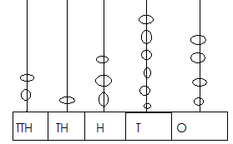

- 20 000 + 1 000 + 300 + 60 + 4

- Thousands

- …
- 1105HRS
- 2.06PM
- 1345HRS
- 0000HRS
- 1201HRS

- …
- 93 170
- 2 672

- …
- 7, 9
- 16,18,20
- 11,13,17,19
- 1

- …
- acute
- obtuse

- …
- 23, 47
- 205, 255, 305

- …
- <
- <
- >
- <
- >
- …
- 160
5 left
161
- 680 leaves

