Grade 4 Mathematics 2015
Mock Examination
Marks: 60
Paper 1
Instructions
- Answer all questions
- Show all necessary working on this sheet
- This paper has two sections. Section A has 20 multiple choice questions
- In section A circle (O) the correct option only on the answer grid provided.

Section A

- 5007
- 517
- 5017
- 23

- tens
- thousands
- hundreds
- one

- 3000+100+50+2
- 300+100+50+20
- 1000+300+20+5
- 3000+50+20

- 7
- 2
- ½
- 4

Question 1
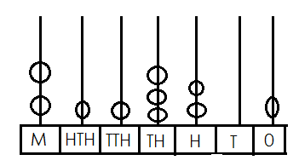
- What is the value of the number shown by the spike abacus?

Question 2
What is the value of five in the number 2005?

Question 3
Write 3152 in expanded form

Question 4
The ½ of 14 is…

Question 5
4 903 written in words is…

Question 6
The shaded fraction is ….

Question 7
At what time does our school start?

Question 8
The missing numbers in the pattern below are:
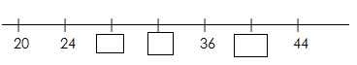

Question 9
6 repeated 3 times is …

- Four thousand nine hundred and three
- Nine hundred
- Four thousand and three
- Four hundred and three

- 2/6
- 4/6
- 1/6
- 3/6

- noon
- midnight
- a.m
- p.m

- 23,24,38
- 28,32,40
- 34,35,38
- 28,30,32

- 18
- 9
- 24
- 20

Question 10
What is the product of 9 and 7?

Question 11
93 when rounded off to the nearest ten is…

Question 12.
What mathematical sentence is shown by the diagram?
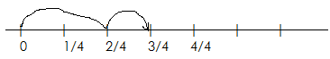

Question 13
12 000m is equal to ___________km

Question 14
The mathematical sentence show by the diagram is_______

- 47
- 61
- 42
- 63

- 100
- 90
- 80
- 95

- ¾ - 2/4
- 2/4 + ¾
- 2/4 + ¼
- 4/4 -1/4

- 2km
- 120km
- 1km
- 12km

- 3x3
- 3x4
- 3÷3
- 3-3

Question 15
- 8
- 10
- 11
- 9

- 1/4, 1/5, 3/8
- 1/5,3/8,1/4
- 1/5,1/4,3/8
- 3/8,1/5,1/4

- (i), (ii) (iii)
- (ii) and (iii)
- (i) and (iv)
- (ii) (iii) (iv)

- 12g
- 120
- 19g
- 52

- 22cm
- 18cm
- 28cm
- 81cm
How many triangles are in the shape below?

Question 16
Arrange the fractions in order starting with the smallest
¼ 1/5 3/8
Question 17
Which of these show angles?
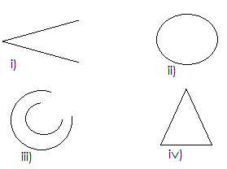

Question 18
Six eggs have a mass of 312g. What is the mass of one egg?

Question 19
Find the parameter of the shape above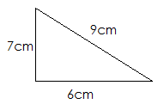
Question 20

- 10grams
- 10 000 grams
- 100 grams
- 1000 grams

1 kilogram = [ ] grams

[40 Marks]

- Angle
- Circle
- Sector
- factor

Section B

- __________________

- ___________________

- ___________________

[3]

Show all working where necessary
Question 21
Write down the shaded fractions
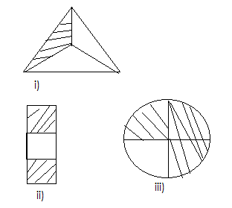

Question 22
Complete the following number patterns
- 31, 33, 35, 37, 39, [ ], [ ]...

- 0, 8, 6, 14, 12, [ ], [ ]…

- AA, AB, AC, AD, [ ], [ ]

[6]

Question 23
Compare the shaded part in the diagrams below, using < > or =
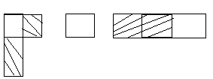
[1]

Question 24

- ________________[3]

- ________________[3]

- ________________[3]

- ___________________[3]

- ____________________[3]

- ____________________[3]
- The Dludlu family has 3 sons, Sibusiso, Nhlanhla and Vincent.
Sibusiso is 6years old, Nhlanhla 4 and Vincent 2.
- Which son is 2years older than Nhlanhla?
- Which son’s age is 2 times the age of Vincent?
- What is the sum of the ages of the boys?

Question 25
A road map of some towns in Swaziland is shown below
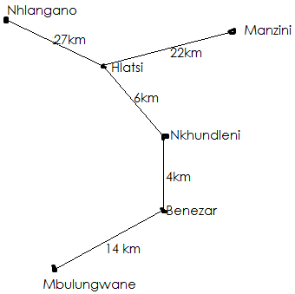
- How far is it from Nhlangano to Nkhundleni

- What is the difference in the distance between Nhlangano and
Hlatsi and between Hlatsi and Nkhundleni
- What would be the total difference travelled if you travel from
Manzini to Hlatsi, Nkhundleni,Benezar, down to Mbulungwane

Question 26

- _________________[2]

- ____________________[2]

- ___________________[3]

- ___________________[3]

Show the following on a number line
- 1/6 + 3/6 = [2]

- 4/4 – ¼ [2]

Question 27
The following table shows the amount of each person had and the cost
of the item he or she bought. Calculate the money they had after buying
the item
 | Amount | Cost of Item
Bongani | E16.35 | E5.80
Vuyiswa | E19.80 | E15.93
Thobile | E11.93 | E8.95

- Vuyiswa’s Change

- Thobile’s change

Question 28

- _________________[2]

- ________________[1]
- ________________[1]
- ________________[1]
- ________________[1]
- ________________[3]

- ___________________[2]

Study the bar graphs and answer the questions

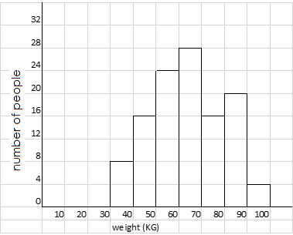
- Suggest a title for the Graph
- What is the least weight of this group of people?
- How many people have a weight of 90kg
- What do most people weigh in this graph?
- What is the total number of people who weigh 40kg and
those who weigh 70kg altogether?

Question 29
Find the perimeter of the object or shape

- ___________________[3]

- ___________________[3]

- _________________[3]

- _________________[2]

- _________________[2]

- ________________[2]

- _______________[3]
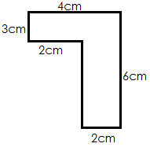

Question 30
Ntombenhle’s Time Table
Study the timeline below and answer the questions that follow
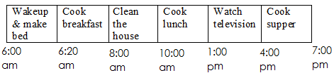

- Which period is longer: watch television or cleaning the house?

- How long did Ntombenhle watch Television?

- How long is it from the start of cooking breakfast to the end of

cooking lunch?

Question 31
Draw line of segment of these distances
- 4cm [1]

- 9cm [1]

Question 32
What is …?

- _________________[2]

- _________________[2]

- _________________[3]

- 1 fourth + 1 fourth

- 2 quarters + 1 quarter

