Section A

- 312
- 123
- 302
- 213

- Thirty hundred
- Three hundred and six
- Three and six
- Thirty six

- 26
- 36
- 46
- 90

- 8+6+3
- 800+60+30
- 800+60+3
- 800+600+3

Question 1
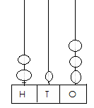
- What is the number shown by the abacus?

Question 2
The number 306 written in words is?

Question 3
What is 63 – 27 equal to?

Question 4
The number 863 in expandable form is..

Question 5

- 6.15
- 7.05
- 7.72
- 7.68

- cube
- rectangular prism
- triangular prism
- triangular pyramid

- 3
- 4
- 5
- 6

- 10, 11, 12
- 12, 15,18
- 10. 12, 14
- 10, 15, 20

- 2/5
- 2/7
- 3/5
- 3/7

There are 133 pupils in grade 3 and 258 pupils in grade 2. How
Many pupils are in grade 2and 3 altogether?

Question 6
The correct name for the solid below is …

Question 7
How many faces does the shape in question 6 have?

Question 8
What are the next three number in this pattern?
3, 6, 9, ______, _______, ________

Question 9
What is the shaded fraction below in the diagram below?

- 2
- 3
- 4
- 5

- 3 + 2
- 3 + 3
- 3 + 4
- 3 + 7

- 2 minutes past 3
- 10 minutes past 3
- 3 minutes past 3
- 3 minutes past 10

- 9 squares
- 10 squares
- 11 squares
- 12 sqaures

Question 10
A square is a shape with ___________ equal sides.

Question 11
Which number sentence is represented by the number line below?
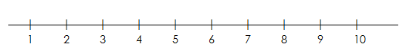

Question 12.
The time on the clock is
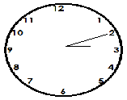

Question 13
What is the area of the figure below?

Question 14
- 3
- 4
- 6
- 8

- Circle and square
- Triangle and rectangle
- Square and rectangle
- Cube and triangle

- 1
- 2
- 3
- 4

- 65
- 75
- 85
- 95

- E0.70
- E1.70
- E50.20
- E70.00

Mr Xulu had 24 apples. He shared his apples equally among 3 children
How many apples will each child get?

Question 15
The shape below is made by which plane shapes?

Question 16
How many lines of symmetry does the shape below have?

Question 17
What is the sum of 60 and 35?

Question 18
Bongani has the following coins in his pocket. How much money does
He have in all?

Question 19
- 6
- 7
- 8
- 9

- 5cm
- 6cm
- 7cm
- 8cm

What is the missing number in the box?
[ ] × 3 = 21

Question 20
The Length of the pencil is___________

[40 Marks]

Section B

- __________________
- __________________
- __________________
- __________________
- __________________

- Side = ________________
Perimeter = ___________

- Side = ________________
Perimeter______________

- ________________[2]

- ________________[3]

Question 21
Compare the numbers using
> < =
- 79 [ ] 709
- 363 [ ] 633
- 100+100 [ ] 200
- 830 [ ] 380
- 42 [ ] 24

[4]
Question 22
Find the missing side and calculate the perimeter of each shape

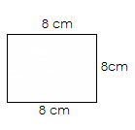

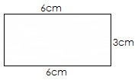 [5]

Question 23
Mr Dlamini has 92 chocolate sweets and 15 rulers. If 35 chocolate
Sweets are sold. How many are left?
- Write down the key numbers in the story.

- What will be the answer?
Question 24

- __________________[2]

b. ___________________ [2]
c. ___________________ [2]

- _________________

- _________________

- _________________

- __________________

- __________________

[10]

Study the diagram below and answer question
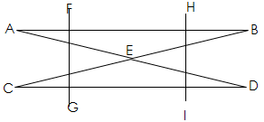
- State 2 vertical lines
- State 2 horizontal lines
- What is the point of intersection of AD and CB

Question 25
Work out:
- 437
- 189
____________

- 4 5 6
- 1 4 5
________________

- 28 ÷ 4 = [ ]
- 6 × 4 = [ ]

- 5 2
- 3 0

Question 26

- ___________________[5]

- ___________________[3]

- ___________________[2]

Draw lines to match numeral to the correct number name.
18 eighty –one
76 sixty seven
81 forty eight
67 eighteen
48 eighty six

Question 27
Write the numbers in expanded form by filling the boxes.
- 893 = [ ] hundreds + [ ] tens + [ ]ones
- 700 = [ ] hundreds + [ ] tens + [ ]ones
- 134 = [ ] hundreds + [ ] tens + [ ]ones

Question 28
Write the value of the underlined digit.
- 408
- 789

Question 29
- There are 20 children at the Somhlolo stadium to watch soccer
Each child paid E3 for entry tickets. How much money was
Collected for the tickets?

- If 13 children left the stadium earlier, how many remained

Question 30

- _________________[2]

- ________________[2]
- ________________[2]

- Draw the minute-hand on each clock to show the written time
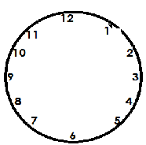15 past 6
10 minutes to 8
- Write the time shown below with 12 hour digital time

Question 31

- ___________________[1]

- ___________________[1]

- ___________________[2]

- ___________________[3]

[2]

[60 Marks]
Grade 3 learners used a bathroom scale to measure their masses and the
Following are masses of learners from one group:
meluleki 33kg, sipho 20kg, Thandiswa 28kg, Fezile 29kg and
Lungelo 28kg
- Who is the heaviest in the group?
- Who is the lightest in the group?
- Who have the same masses?
- What is the total mass of the learners in that group

Question 32
Draw all lines of symmetry in the shape below.

