Grade 2 Mathematics 2015
Marks: 60
Question 1
Fill the missing number
- _____, 10, ______, 20, _______, _________

- 100, 90 _______, _________, ________

- 14, 12, 10, ________, ________, __________
[10]
Question 2
Write down the names of the following shapes

[4]
B. WRITE THIS WORD PROBLEMS AS NUMBER SENTENCES
- Mom had 3 oranges
I gave her 4 more oranges
How many oranges did she have?

- There were 13 apples in a tree
4 fell off the tree

How many apples were left?
[6]

Question 3

Circle the correct member of each set.

Tenth | O O O O O O O O O O O O | 10TH
Thirteenth | + + + + + + + + + + + + + | 13th
Fifth | Q Q Q Q Q Q Q Q Q Q Q | 5TH
Eleventh | V V V V V V V V V V V V V V V | 11TH
Fifteenth | [] [] [] [] [] [] [] [] [] [] [] [] [] [] [] [] [] [] [] [] | 15TH
[5]
Question 4
- Write add or even to the following numbers.

2 _______________________________

3 _______________________________

9 _______________________________

12 ______________________________
[4]
Question 5
State how many tens and ones re there.
- ..
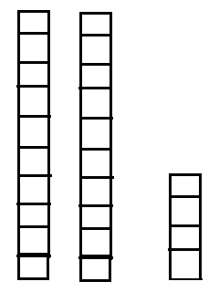
Tens ones

- ….
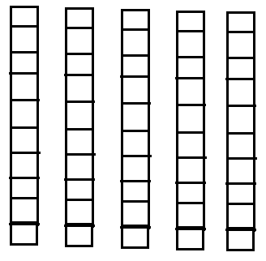
Tens ones

- How many tens and ones are there altogether?

Tens |  | Ones |  | Total
6 | + | 9 | = | 69
1 | + | 2 | =
4 | + | 7 | =
5 | + | 0 | =
2 | + | 8 | =
[8]

- Use the bundles to show the following numbers

e.g. 13 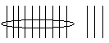

- 15

- 26

- 53
[3]

Question 6
- Show the times on the clock

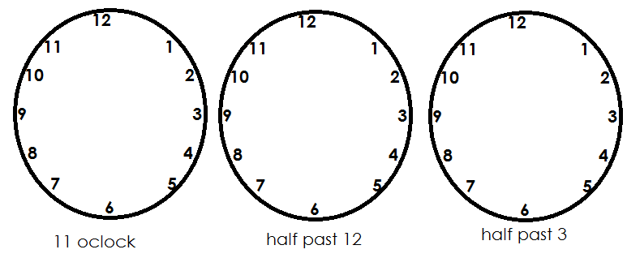

- Divide each shape into two equal part and shade ½ (half) of each shape.
- … ii)

[4]
Question 7
Complete the table below by writing the numbers either in words or numbers
Numeral | Word
12
 | Nine
 | Six
5
 | ten
[5]
Question 8
Write in the missing number.
- 5 b. 9 c. 5
+ 6 - 2 + 3

D 1 e. 1 0
+ 9 - 3 [5]

