Grade 2 Maths 2015
Marking Guide
Question 1
- 5, 15, 25, 30
- 80, 70, 60
- 8, 6, 4
Question 2
- …
- Square
- Rectangle
- Triangle
- Circle

- ,,,
- 3 ii) 13
+ 4 - 4
7 9
Question 3
Tenth
13th
5th
11th
15th
Question 4
2 - Even
3 - odd
9 - odd
12 - Even
Question 5
- 24
- 50
- …
12
47
50
28

- …
- 15
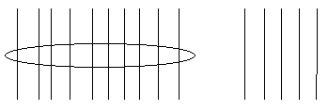
- 26
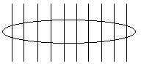

- 53
Question 6

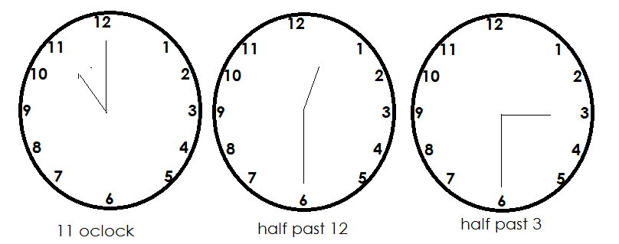

- … b….
Question 8
Twelve
9
6
Five
10
Question 8
- 11 d. 9
- 7
- 5 e. 3`

