Question 1
Continue the pattern in each row
- Abac abac abac ______ _______ _______

- OAOAOA _________ _______ ____________
[6]
Question 2
TICK (4) heavier one in each pair

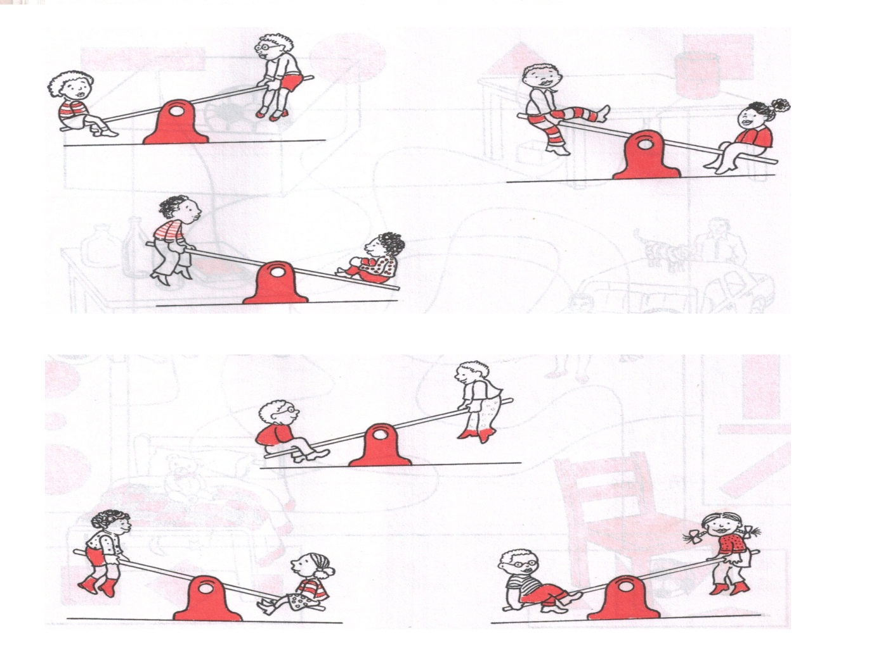
[3]

Question 3

Match the days of the week

- Tuesday Umsombuluko

- Friday Lisontfo

- Sunday lesitsatfu

- Monday lesibili

- Wednesday lesihlanu
[5]

Question 4
TICK (4) what comes first on the same day
- Afternoon [ ] Morning [ ]

- Noon [ ] afternoon [ ]

- Morning [ ] evening [ ]

- Sunset [ ] sunrise [ ]
[4]

Question 5
Write T if it is correct and F if it is wrong.
- These sets have the same number of members

- Morning comes first than afternoon

- A paper floats on water

- This is a set of circles

[5]

- A triangle has 2 corners

Question 6
- Draw a set with 4 numbers

[3]
Question 7
Put a ring around early or late
Thoko was supposed to come to school in the morning but she arrived in the afternoon, was she early or late? | Early | Late
If you were supposed to come at noon and you arrived in the morning, were you early or late | Early | Late
Lili was supposed to come in the afternoon but she arrived in the morning, was she early of late | Early | Late
Siphon was supposed to go to town in the morning but he decided to go at noon. Was he early or late | Early | Late
[4]

Question 8
Write the number sentence in the boxes.
One is done for you.

2 plus 3 gives 5

Plus gives

Plus gives

Plus gives

[6]

Question 9
Work out
- 1 + 3 =

- 2 + 3 =

- 3 + 2 =

- 4 + 2 =

[4]

Question 10
Write down the answers for these problems
- Pat has 6 ballons.
He gets 3 ballons more.
How many balloons do they have altogether? [2]

- Wenzi has 2 balls
Fezi has 1 ball
How many balls do they have altogether? [2]

Question 11
Write the correct numbers in the boxes.
The first one is done for you.

3
5
2
- =

- =

- =

[6]

