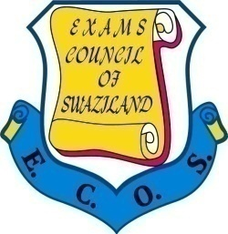**EXAMINATIONS COUNCIL OF SWAZILAND**

**JUNIOR CERTIFICATE EXAMINATION**

**History** **530/01**

Paper 1 **October/November 2014**

**2 hours**

**Additional Material:** Answer Booklet

**READ THESE INSTRUCTIONS FIRST**

Answer **4** questions in all.

Answer **2** questions from **Section A** and **2** questions from **Section B**.

Write your **name, centre numbe**r and **candidate number** on the Answer Booklet.

This question paper consists of **7** printed pages and **1** blank page.

**SECTION A**

Answer question **1** and any other question. Each question is divided into **three** parts. Answer **all parts** of the question you choose. Each question carries **15 marks.**

**QUESTION 1**

Study the source below and answer the questions that follow.

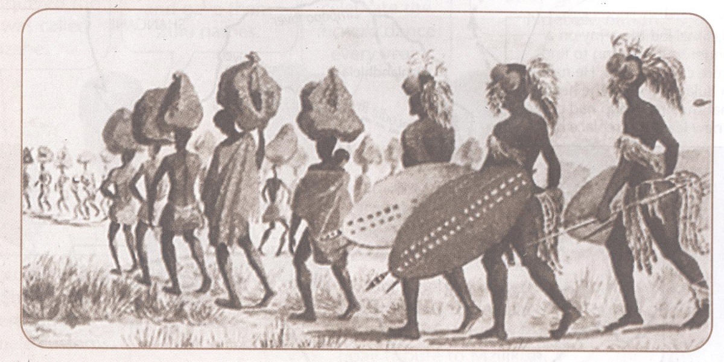

*Nguni warriors during the Mfecane*

(a) What was the Mfecane? [3]

(b) Explain why Sobhuza I decided to run away from Zwide’s attacks. [5]

(c) Marriage was the most important nation building strategy that king Sobhuza I

used when building the Ngwane nation. How far do you agree with the

statement?

Explain your answer giving both sides of the argument. [7]

**QUESTION 2**

Study the source below and answer the questions that follow.

When you study history, you need to be aware of who is writing the history, what sources they use, what sources they do not use, why they are writing history and for whom.

*From a History book published in 2007.*

(a) Describe any **one** type of primary source that historians use to write history. [3]

(b) Explain why it is important to use many sources in history. [5]

(c) ‘History is a very important subject and it should be taught in all schools.’

How far do you agree with the statement? Explain your answer giving both

sides of the argument. [7]

**QUESTION 3**

Study the source below and answer the questions that follow.

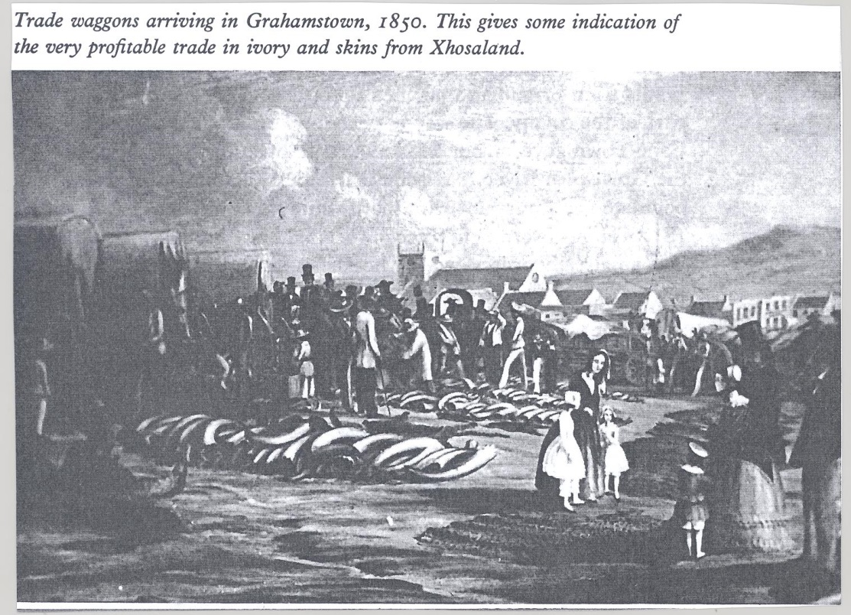

*Trade wagons arriving in Grahamstown, 1850.*

(a) Who were the 1820 Settlers? [3]

(b) Explain why the 1820 Settlers came to South Africa. [5]

(c) ‘It was the abolition of slave trade and slavery which caused the Great Trek’.

How do far do you agree with the statement? Explain your answer giving both

sides of the argument. [7]

**SECTION B**

Answer question **4** and any other question. Each question is divided into **three** parts. Answer **all** **parts** of the question you choose. Each question carries **15 marks.**

**QUESTION 4**

Study the photograph below and answer the questions that follow.

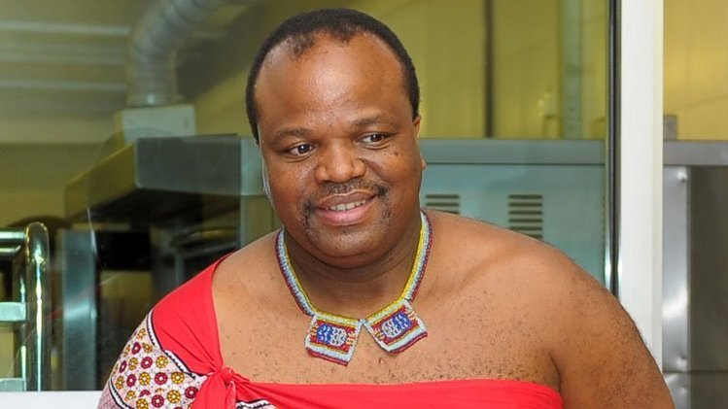

*King Mswati III*

(a) Describe any **one** contribution made by King Mswati III to the development of

the Swazi nation. [3]

(b) Explain why SADC was formed. [5]

(c) ‘Swaziland should **not** withdraw her SACU membership.’ How far do you

agree with the statement? Explain your answer giving both sides of the

argument. [7]

**QUESTION 5**

Study the photograph below and answer the questions that follow.

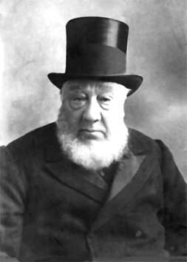

*Paul Kruger*

(a) What **three** grievances did the Boers have against the British as a result

of the South African war, 1899 – 1902? [3]

(b) Explain why the Migrant labour system was favoured by mining companies. [5]

(c) ‘The main reason for discriminating against non-whites in the inter-war period

was economic’. How far do you agree with the statement? Explain your answer

by giving both sides of the argument. [7]

**QUESTION 6**

Study the source below and answer the questions that follow.

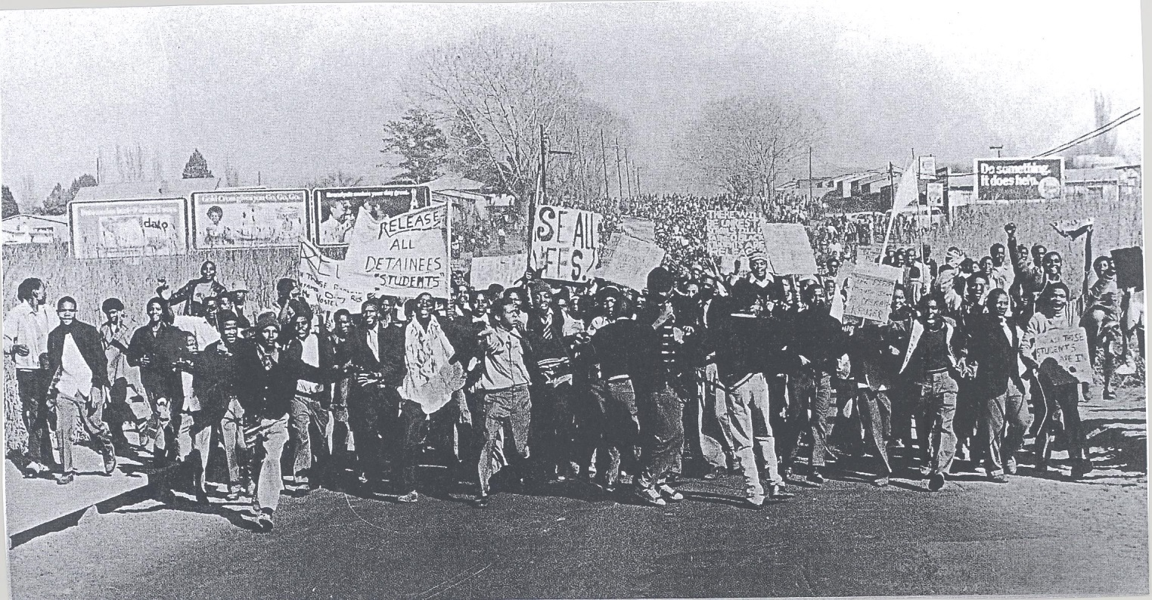

*African demonstrators*

(a) Describe the events of 16 June 1976 in Soweto. [3]

(b) Explain why Steve Biko was important in the history of South Africa. [5]

(c) ‘International opposition was the most important factor which led to the

collapse of Apartheid.’ How far do you agree with the statement? Explain

your answer giving both sides of the argument. [7]

_________________________________