
EXAMINATIONS COUNCIL OF SWAZILAND
JUNIOR CERTFICATE EXAMINATION

Religious Education 533
October /November 2014
2 Hours 30 Minutes
Additional Material: Answer Booklet / Paper

READ THESE INSTRUCTIONS FIRST
Write your name, centre number, and candidate number on all the work you hand in.

Answer SEVEN questions.

SECTION A : Answer all questions.
SECTION B : Answer one question.
SECTION C : Answer one question.
SECTION D : Answer two questions.
At the end of the examination, fasten all your work securely together.
The number of marks is given in brackets [ ] at the end of each question or part question.

This document consists of 11 printed pages and 1 blank page.

SECTION A

Answer all questions in this section. Each question carries 10 marks.

- JUDAISM

- What is the name of the festival that celebrates the
Jewish victory over Persian Gentiles? [1]

(b) Mention three things done during this festival. [3]

(c) Explain three important teachings of this festival. [6]

- CHRISTIANITY

(a) Name any one place of worship in Christianity. [1]

(b) Name any three features found in a place of worship in
Christianity. [3]

- Explain how any three objects that help Christians
during worship. [6]

3. ISLAM

- Name any one place where a wedding ceremony is
conducted in Islam? [1]

(b) Mention any three people that are necessary in a Muslim
wedding. [3]

(c) Explain three reasons that make marriage important for
Muslims. [6]

SECTION B
Answer one question in this section. Each question carries 24 marks.

- (a) Define a fast. [4]

(b) For each of the religions studied (Judaism, Christianity and
Islam) state [6]

- the original language of the sacred books

(ii) the place of origin

(c) Describe the role played by [6]

- Moses in Judaism
- Holy Spirit in Christianity
- Muhammad in Islam.
(d) Explain the importance of the following in religion [8]

- Supreme Being

- Myths

- Rites of Passage

- Pilgrimage.

- (a) According to Judaism and Christianity, how was the state
of the world before creation? [4]

(b) For each of the following religions, Judaism, Christianity
nd Islam, state the purpose for which human beings were
created. [6]

(c) Describe any three role played by rites of passage in the
life of a believer. [6]

(d) Explain four advantages of practicing religious tolerance for
believers. [8]

6. (a) Give four reasons why believers pray. [4]

(b) For each of the religions studied, (Judaism, Christianity and
Islam) mention two places of pilgrimage. [6]
(c) Explain three important functions of a religion. [6]

(d) Explain the beliefs shown in the following speeches (include the
names of the people that hold such beliefs)

- “I am not sure whether there is God or not ”. [2]

- “The many gods I worship, the happier I am”. [2]

- “With all the pain and suffering in the world, God is
just a myth”. [2]

- “I shall worship one God”. [2]

SECTION C
Answer any one question in this Section. Each question carries 24 marks.

7. (a) JUDAISM

Carefully study the source below and answer the questions that follow.

Source A

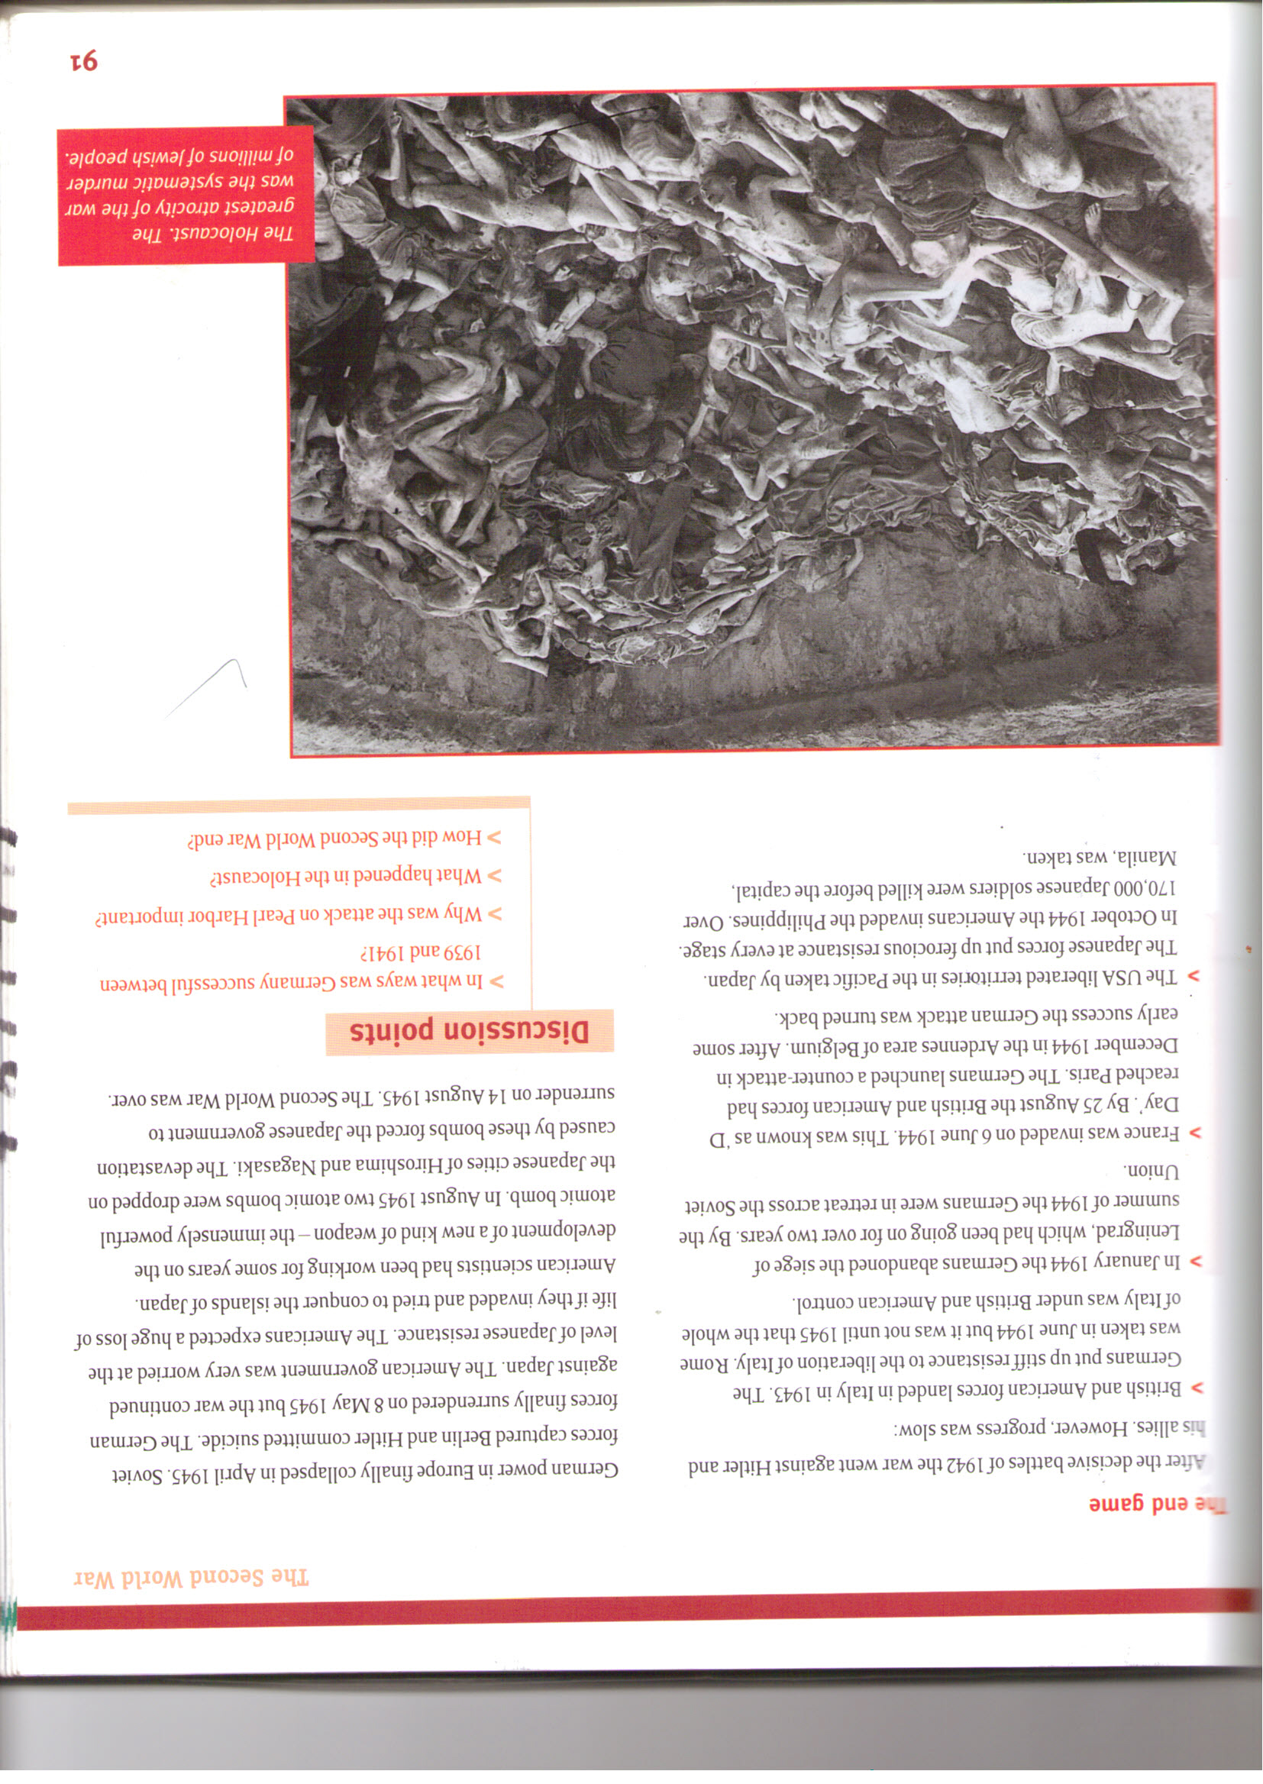

- What do you think is the cause of what is shown in the
source? [1]

- State two categories of war in Judaism. [2]

- Do you think there would be no conflict if there were
no religions? Give reasons for your answer and show you
have thought about different points of view. [5]

(b) CHRISTIANITY

Carefully study the source below and answer the questions that follow.

Source B

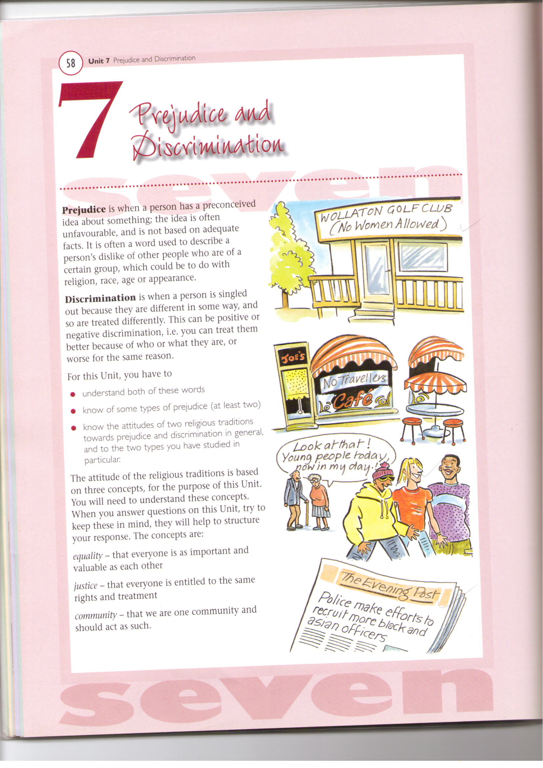

- What do you think is the message in Source B ? [1]

- Mention two causes of what is shown in the source. [2]

- Do you think Christian churches promote inequality?
Give reasons for your answer and show you have
thought about different points of view. [5]

(c) ISLAM

Read the following source and answer the questions that follow.

Source C

“If you fear a breach (break) between a man and his wife, appoint an arbiter [mediator] from his people and another from hers. If they wish to be reconciled, God will bring them together again. Surely God is all-knowing and wise”
(Surah 4.35)

- Mention one cause of the situation described in the
Source. [1]
- How do Muslims try to prevent married couples from
divorcing? [2]

- Do you think a man should take full responsibility for his
ex-wife and her children? Give reasons for your answer
and show you have thought about different points of view. [5]

8 (a) JUDAISM

Carefully study the source below and answer the questions that follow.

Source D

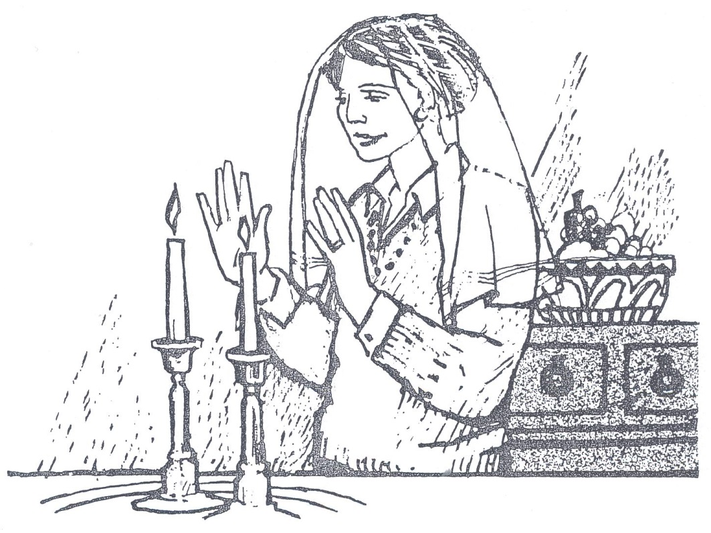

- What do you think is the place of worship shown in the
Source? [1]

- Briefly describe the responsibility of a Jewish mother
that is shown in the source. [2]

- Do you think a woman’s place is in the kitchen in Judaism?
Give reasons for your answer and show that you have
thought about different points of view. [5]

(b) CHRISTIANITY

Carefully study the source below and answer the questions that follow.

Source E

- What is the condition shown by the Source? [1]

- Give two reasons why Christians should help others. [2]

- Do you think the relief of human need should be left to
the church? Give reasons for your answer and show that
you have thought about different points of view. [5]

(c) ISLAM

Carefully read the source below and answer the questions that follow.

Source F

I’m in severe pain, please help me die peacefully!
“I will give no deadly medicine to anyone if asked, nor suggest such counsel”
A doctor’s Hippocratic Oath

- What type of Euthanasia is suggested in the Source? [1]

- What is the teaching of Islam about Euthanasia? [2]

- Do you think doctors should assist someone to die?
Give reasons for your answer and show that you have
thought about different points of view. [5]

SECTION D
Answer any two questions in this section. Each question carries 12 marks.

9. (a) (i) How are the traditions that govern the life of the Swazi
believer passed on? [1]

(ii) Name three places where knowledge and practices of the
Swazi are taught. [3]

(b) (i) Describe the role of the dual monarchy in Swazi Traditional
Religion. [4]

(ii) Explain two functions of songs in Swazi Traditional
Religion. [4]

10. (a) (i) Name the main form of worship in Swazi Traditional
Religion. [1]
(ii) Mention any three places of worship in Swazi Traditional
Religion. [3]
(b) (i) Explain the importance of any two religious objects used
during protective rituals in Swazi Traditional Religion. [4]

(ii) Explain two ways by which family elders nurture the young
in Swazi Traditional Religion. [4]

11. (a) (i) Name the place from which Swazi pilgrims are commissioned
for pilgrimage. [1]

(ii) Name three main participants of the pilgrimages undertaken
in Swazi Traditional Religion. [3]

(b) (i) Mention four major periodic festivals in Swazi Traditional
Religion. [4]

(ii) Explain the significance of any two pilgrimages in
Swazi Traditional Religion. [4]

___________________________________

