**EXAMINATIONS COUNCIL OF SWAZILAND**

**JUNIOR CERTIFICATE EXAMINATION**

|  |
| --- |
|  |

CANDIDATE

NAME

CENTRE CANDIDATE

NUMBER NUMBER

**Agriculture 516/01**

Paper 1 **October/November 2014**

**1 hour 30 minutes**

**READ THESE INSTRUCTIONS FIRST**

1. Write your **Centre Number**, **Candidate Number** and **Name** in the spaces provided above.

2. Answer **ON THE QUESTION PAPER** by completing each question as instructed.

3. Work quickly. If a question seems hard, skip it and come to it later.

4. You can make your answers quite short and clear.

|  |  |
| --- | --- |
| ***For official use*** | |
| ***Marks obtained*** |  |

This paper consists of **15** printed pages and **1** blank page.

1. (a) What is the most important agricultural asset in Swaziland?

.............................................................................................................................. [1]

(b) Why does Swaziland depend on agriculture? Give any **two** reasons.

(i) ..................................................................................................................

(ii) ..................................................................................................................

[2]

(c) Describe these **two** types of farming systems.

(i) Subsistence farming .............................................................................

................................................................................................................

(ii) Cash farming .............................................................................

................................................................................................................

[2]

2. (a) Give any **two** causes of accidents in a farm when using tools and equipments.

(i) ................................................................................................................

................................................................................................................

(ii) ................................................................................................................

................................................................................................................

[2]

(b) What factors should a farmer consider when using tools and implements /

equipment. Give any **three**.

(i) ................................................................................................................

................................................................................................................

(ii) ................................................................................................................

................................................................................................................

(iii) ................................................................................................................

................................................................................................................

[3]

3. Use the knowledge gained in class to complete this table.

|  |  |  |  |
| --- | --- | --- | --- |
| **Vegetable** | **Pest/Disease** | **Damage caused** | **Control Method** |
| Carrot, cabbage  tomato, beans | (i) | Feed on plant juice and slow plant growth. | (ii) |
| Tomato, potato | (iii) | Dark brown or black spot on leaves.  Leaves turn yellow and fall off. | Spray with a mixture of Dithane 80% WP  10g and copper oxychloride  20g in 5 litres of water. |
| Cabbage | (iv) | Plant eaten at ground level. | (v) |

[5]

4. (a) You are making a seedbed and later planting in the seedbed.

(i) State **one** reason for planting some vegetables in a seedbed.

..................................................................................................................

..................................................................................................................

(ii) Why should the seedbed be raised?

..................................................................................................................

..................................................................................................................

(iii) Why should the mulch be removed once the seeds have germinated?

..................................................................................................................

..................................................................................................................

..................................................................................................................

[3]

(b) Njabulo and Mandla transplanted their seedlings on the same day. The table below shows how many plants survived, two weeks after transplanting.

|  |  |  |
| --- | --- | --- |
|  | **Number of plants** | **Number of Living plants**  **after two weeks** |
| Njabulo  Mandla | 40  40 | 35  14 |

Give any **two** reasons that could have made Mandla’s seedlings die.

1. .............................................................................................................................

(ii) ............................................................................................................................. [2]

5. Study the diagram and answer the questions that follow.

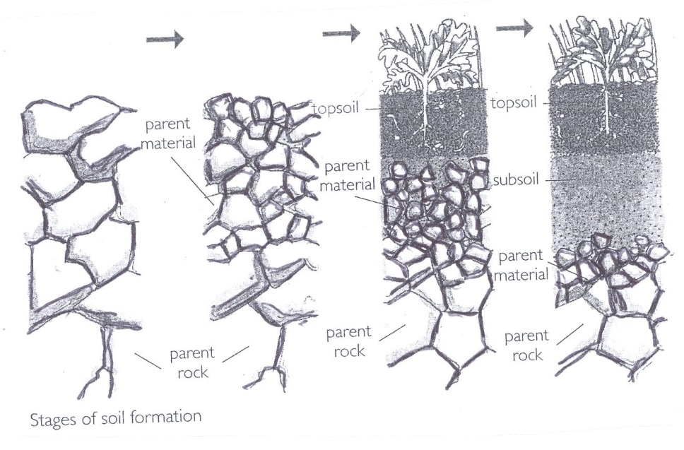

Parent

Parent

rock

material

Parent

Parent

Stages of soil formation

Parent

material

material

topsoil

rock

Parent

rock

subsoil

topsoil

1. (i) What is parent material?

..................................................................................................................

..................................................................................................................

(ii) How is the subsoil formed?

..................................................................................................................

..................................................................................................................

(iii) How is the top soil formed?

..................................................................................................................

..................................................................................................................

[3]

1. Why is the subsoil more compacted than top soil?

.............................................................................................................................

.............................................................................................................................

............................................................................................................................. (1)

1. The compacted soil can form a hard layer that stops water from draining

properly and the soil becomes waterlogged.

What is the effect of the waterlogged soil on the plants?

.............................................................................................................................

............................................................................................................................. [1]

6. (a) What is nutrient cycle?

.............................................................................................................................

.............................................................................................................................

............................................................................................................................. [1]

(b) Suggest any **two** factors that affect the amount of nutrients that are contained in a

land that has been previously cultivated.

(i) .................................................................................................................

(ii) ................................................................................................................. [2]

(c) Suggest **two** things a farmer can use to prevent yield from falling in their fields.

(i) .................................................................................................................

(ii) ................................................................................................................. [2]

7. The diagram shows a four year crop rotation.

Year 1

Maize

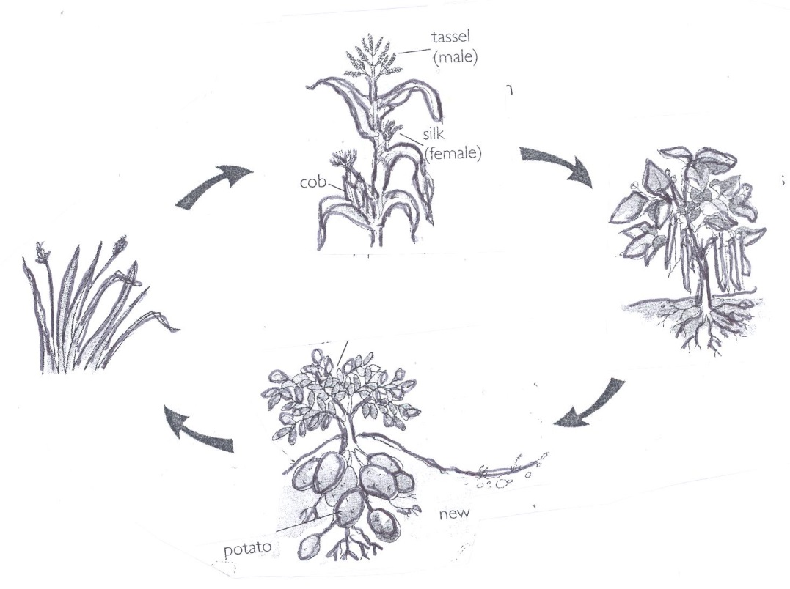

tassel

(male)

(female)

silk

cob

Year 4

grass

Year 2

Beans

new

potato

Year 3

Potatoes

1. (i) What is meant by a four – year rotation?

.................................................................................................................

................................................................................................................. [1]

(ii) Why is grass included in the crop rotation?

.................................................................................................................

................................................................................................................. [1]

(iii) Why is it **not** recommended that grass follow sorghum in the rotation?

................................................................................................................. [1]

1. State any **two** benefits of crop rotation.

(i) .................................................................................................................

(ii) ................................................................................................................. [2]

8. (a) Why is each of the following practices important in crop production?

(i) Seed dressing .........................................................................................

.................................................................................................................

.................................................................................................................

(ii) Ridging of potatoes .............................................................................

.................................................................................................................

.................................................................................................................

(iii) Topping .........................................................................................

.................................................................................................................

.................................................................................................................

[3]

(b) What could be the major reason for importing maize every year in Swaziland?

............................................................................................................................

............................................................................................................................ [1]

1. Why would Milling Companies reject or pay less for maize sold by farmers?

............................................................................................................................

............................................................................................................................ [1]

9. State whether each of the following statements is true or false.

(a) Moulds belong to fungi .................................................

(b) Moulds like damp and warm conditions ............................................

(c) The spout in grain tank helps to get rid of fumes .....................................

(d) Acetylic 2% dust is a systemic insecticide .......................................

(e) Sweet potatoes are cured after harvesting .......................................

[5]

10. (a) Name the **two** chicken vices.

(i) .................................................................................................................

(ii) .................................................................................................................

[2]

(b) What could be **two** advantages of keeping poultry under intensive system.

(i) .................................................................................................................

(ii) .................................................................................................................

[2]

(c) What causes coccidiosis in chickens?

............................................................................................................................. [1]

11. (a) What **three** things are to be considered before selecting tree species when

establishing a forest?

(i) .................................................................................................................

(ii) .................................................................................................................

(iii) .................................................................................................................

[3]

(b) Why is fire the biggest enemy of the forest?

............................................................................................................................

............................................................................................................................ [1]

(c) Why is pruning important in pine trees?

............................................................................................................................ [1]

12. (a) (i) What is grafting? ................................................................................

...................................................................................................................

................................................................................................................... [1]

(ii) State **one** advantage of grafting.

..................................................................................................................

.................................................................................................................. [1]

(iii) Why is most grafting done in Spring?

..................................................................................................................

.................................................................................................................. [2]

(b) Suggest **one** reason for applying fertilizer along the dripline in fruit trees.

..............................................................................................................................

.............................................................................................................................. [1]

13. A bar chart representing the amount in grams of various food crops per 125 g cooked

food. Use the bar chart to answer the questions that follow.

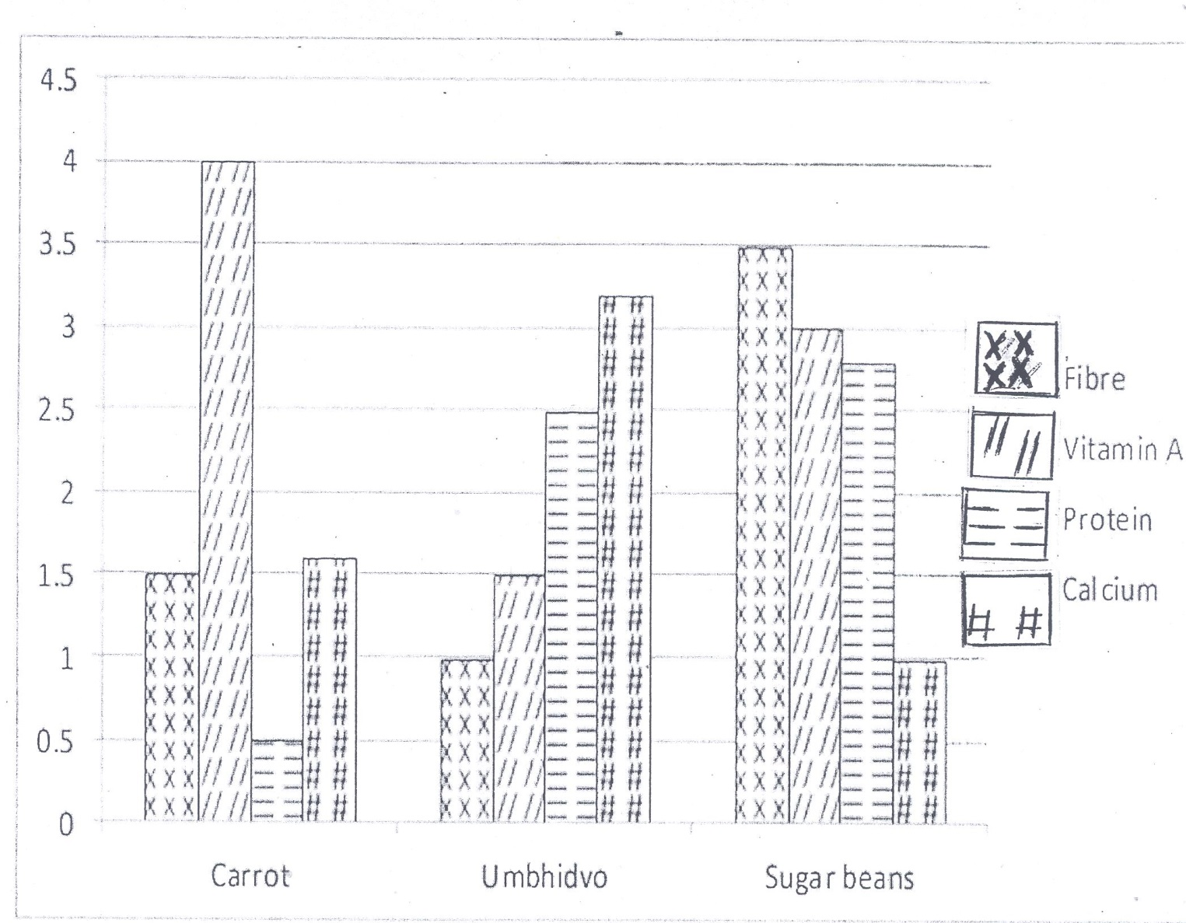

1. (i) Which food crop does **not** provide Vitamin A?

................................................................................................................. [1]

(ii) Which crop has a higher mineral content?

................................................................................................................. [1]

(iii) Which food crop contains more vitamin A?

................................................................................................................. [1]

1. (i) What is the importance of dietary fibre?

.................................................................................................................

(ii) What happens when the vegetables are cooked for too long?

.................................................................................................................

[2]

14. State any **five** things farmers can do to change their plant environment in order to improve crop yield.

(a) ..............................................................................................................................

(b) ..............................................................................................................................

1. ..............................................................................................................................

(d) ..............................................................................................................................

(e) .............................................................................................................................

[5]

15. Fill in the blanks in the following statements.

(a) A goat comes on heat every ……days.

(b) Goats are sexually mature at ………months of age.

(c) ……………………..is the first milk produced after the goat has given birth.

(d) The gestation period in goats is ……………………………

(e) The heat period in goats usually last for ………………………days.

[5]

16. (a) What are the **four** components of cattle supplements?

(i) ..................................................................................................................

(ii) ..................................................................................................................

1. ..................................................................................................................

(iv) .................................................................................................................

[4]

(b) Suggest **one** reason for providing concentrates to animals.

..............................................................................................................................

.............................................................................................................................. [1]

17. (a) List **four** features of a good natural pasture.

(i) ..................................................................................................................

(ii) ..................................................................................................................

1. ..................................................................................................................

(iv) .................................................................................................................

[4]

(b) What is the effect of overgrazing?

..............................................................................................................................

.............................................................................................................................. [1]

18. (a) What is Planning?

..............................................................................................................................

.............................................................................................................................. [1]

(b) Farmer Sibiya grew 5 hectares of maize, 2 hectares of beans and 0.25 hectares

of sweet potatoes. The profit obtained from these enterprises were:

1. Maize - E4000-00
2. Beans - E2000-00
3. Sweet potatoes - E 750-00

Calculate the profit per hectare of the following crops. Show your calculations.

1. Maize .......................................................................................................

...................................................................................................................

................................................................................................................... [2]

1. Sweet potatoes ...............................................................................

...................................................................................................................

................................................................................................................... [2]

19. List the **five** advantages of Nguni cattle over foreign breeds.

(a) ..............................................................................................................................

(b) ..............................................................................................................................

(c) ..............................................................................................................................

(d) ..............................................................................................................................

(e) .............................................................................................................................

[5]

20. (a) Mention any **three** activities of disease control carried out by animal health within the

Department of Veterinary Services.

(i) .................................................................................................................

(ii) .................................................................................................................

1. .................................................................................................................

[3]

(b) Suggest why it is important to control schedule diseases in livestock.

(i) .................................................................................................................

(ii) .................................................................................................................

[2]

____________________________________________________________