Grade 3 English Examination paper 1 2nd Term

Part 1
Draw a picture of your mother, colour it neatly and complete the sentences.
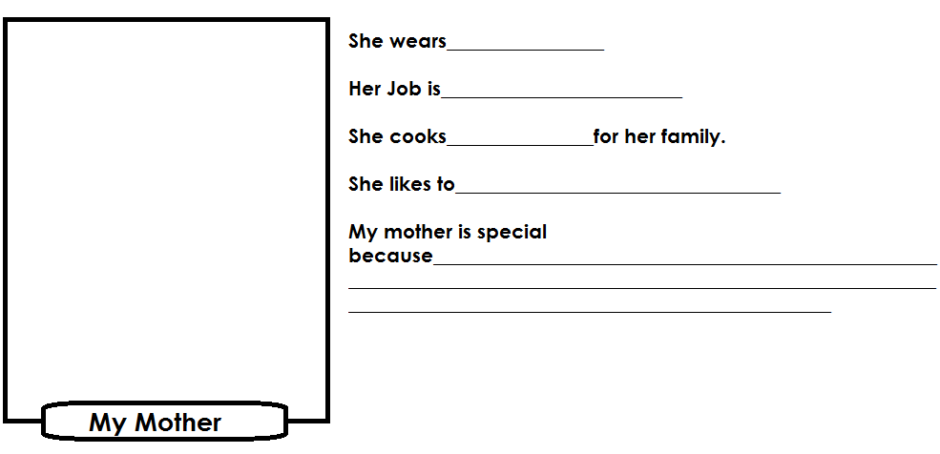

Part 2
Write a letter to your cousin. Tell him or her about the friend you like most.

Phumtile Primary School
P.o. box 21
Manzini
____August________
Dear_____________
I want to tell you about the friend I like most. The name of my friend is ___________________________________________. She/he is ______________years old. He/ She goes to ______________________________ primary school.
He/ She is in Grade _______. My friends’ teacher is_________________________________.

He/ she lives in _________________________________. He/ she lives with ___________________________. Her/ his mother works in _________________________ and his/her father works in_______________________________.

I like my friend because___________________________________________________________

Your Cousin

____________________________________
[15]

Part 3
Draw traffic lights. Colour them correctly and write their meanings

[15]

Drawing = 6marks
Colouring = 3marks
Labelling = 6marks

