Grade 4 Practical Arts Marks: 50

Name: _____________________________________________________________
Instructions: Answer all questions.
Section A Multiple Choice
Choose the correct answer and circle the letter.
- Which of the following items is not woven?
- Basket
- Sun hat
- Mat
- Emajobo

- Which of the following is a function of a paint brush?
- Writing letters
- Cutting wood
- Painting pictures
- Colouring pictures

- A pet needs to be _________________ in order to be clean.
- Clean
- Washed
- Exercise
- Shelter

- _______________ is used for watering seedlings.
- Girl
- Ladder
- Bucket
- Watering can

- Which of the following type of wood is used for making a string pin.
- Pine tree
- Umkhiwa
- Gum tree
- Umgwava

- Choose one example of a dry heat.
- Steam
- Boiling water
- Hot oil
- Flame

- Which of the following is not an example of a burn?
- Scald
- Burn
- Lump of a burn
- Graze

- ________________ is not used to treat a graze.
- Cold water
- Face cloth
- Petroleum jelly
- Bowl

- A person who had a nose bleed must breath through his
- Nose
- Ears
- Eyes
- Mouth

- Which animal is not a domestic animal?
- Monkey
- Chicken
- Cat
- Dog

Section B
Write burn or scald to each of the following pictures
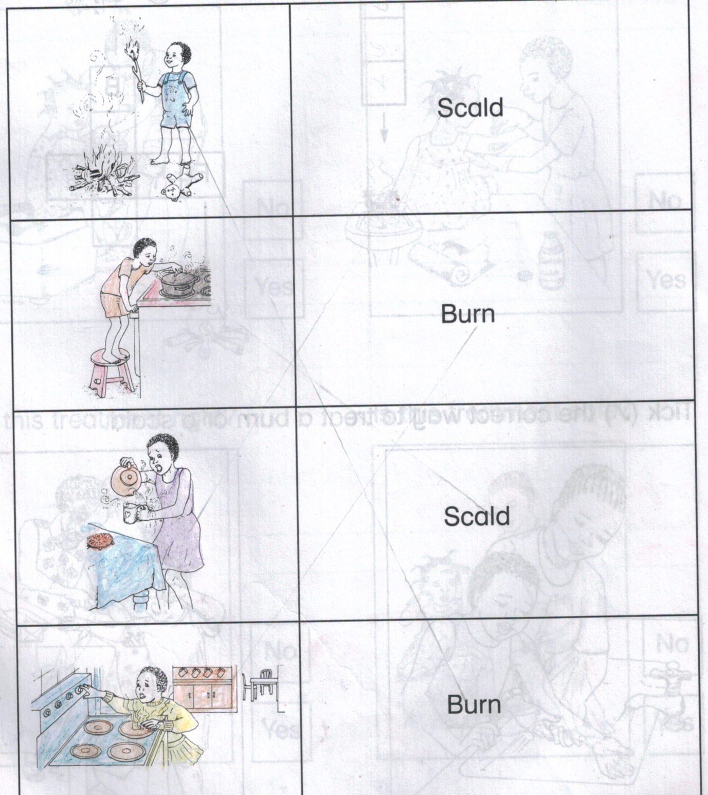

Section C
- Tick all the items that can cause cuts in the box below.
Plate
Pair of scissors book
Tin
knife razor Wood
bottle

- Tick all the materials that you can use to treat a cut in the box below.

Water
gloves
clean cloth bandage
Vaseline

hospital plaster
injection

- Copy and complete the following sentence.

A nostril is a_______________________________________________________

Section D

Use the following words to fill in the blanks.

Shelter, clean, pet, wash, exercise, small, pest, diseases, washing and river.

- After handling pets we should _______________ our hands.
- An animal needs to ________________ to keep it fit.
- A pet feeding utensil should be kept _________________ at all times.
- A distractive animal that attacks crops is a______________
- A_______________ is an animal that we keep at home.

Section E
- Draw and colour a picture of your pet eating and name it.

- List any three ‘’domestic’’ animals.
____________________________________________________________________________________________________________________________________________________________________________________

- Name any two ‘’wild’’ animals.
________________________________________________________________________________________________________________________

- Find and circle these words.

Washing, food, river, spring, watermelon, melon, tomato, healthy

- Name any two uses of water.
________________________________________________________________________________________________________________________

